**APPLICATION DEPLOYMENT**

**(GUVI CAPSTONE PROJECT)**

**Step1. Clone Repository and Deploy Application**

First, you need to clone the repository from GitHub and deploy the application.

Cloned the given URL- <https://github.com/sriram-R-krishnan/devops-build>

Command: git clone URL

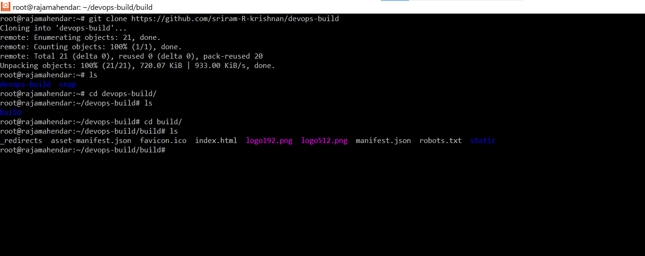

### 

### **Step2. Docker**

Created Dockerfile in the root of the project(devops-build) to define the environment and dependencies required to run the application.

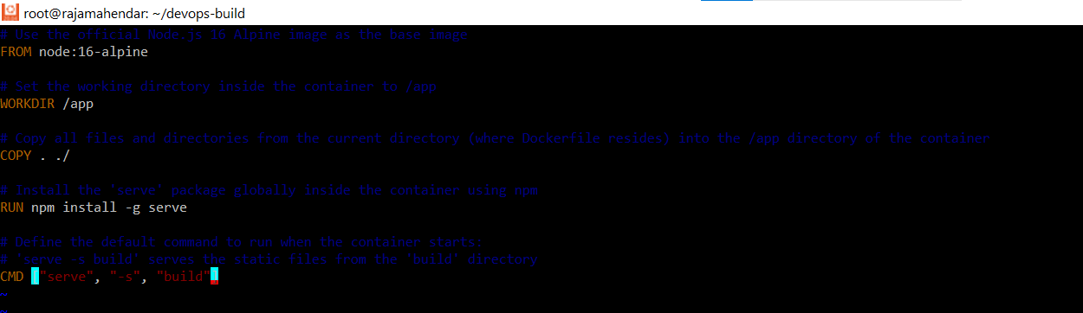

Create a docker-compose.yml file to specify services, networks, and volumes. This will help manage multiple Docker containers for the application.

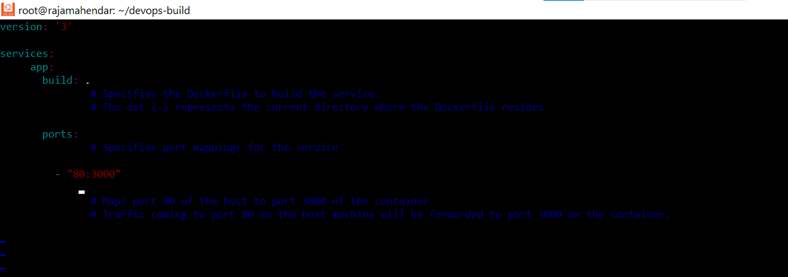

### **Step3. Bash Scripting**

**Created build.sh** file: script (build.sh) that automates the building of Docker images. This script should run docker build commands.

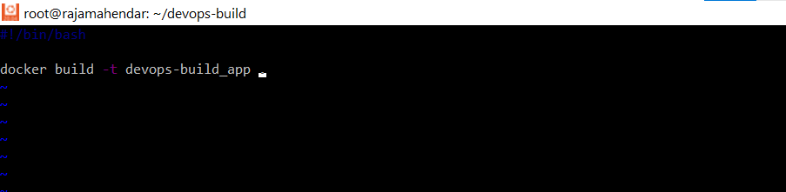

**Created deploy.sh** : script (deploy.sh) to deploy the Docker images to the server. This script may involve pulling the images from Docker Hub and running containers.

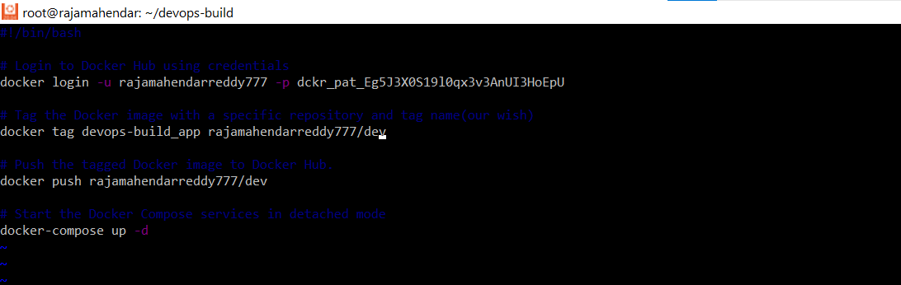

Given permission to build.sh and deploy.sh files



Created .gitignore file

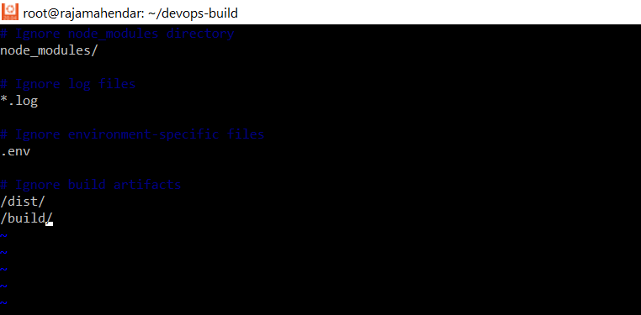

Created .dockerignore

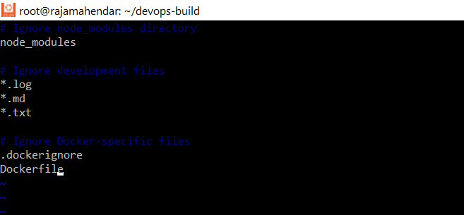

.gitignore and .dockerignore files are used to specify which files and directories should be ignored by Git and Docker, respectively.

This helps keep your repositories and Docker images clean and avoids unnecessary clutter. Make sure to customize these files according to your project's specific requirements and file structure.

**NOTE:**

Installed npm for my project requirement

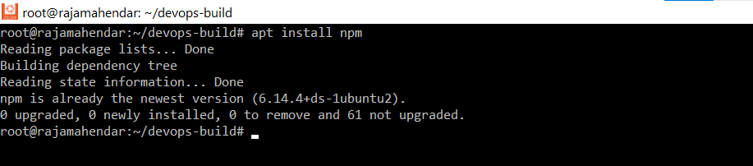

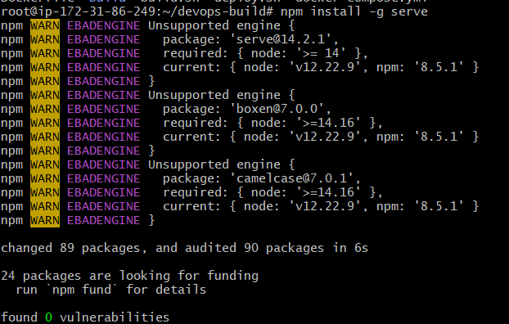

### **Step4. Version Control**

#Create one repository (Reactapp-Application)

Configure Github from gitbash

*git config --global user.name "Your Name"

*git config --global user.email "[youremail@example.com](mailto:youremail@example.com)"

*Generate ssh-key and add to github —->SSH Keys

\***create a new repository on the command line**

git init

Git add .

git commit -m "first commit"

git branch -M dev

git remote set-url origin git@github.com:Rajamahendarreddy777/aa.git

git push -u origin dev

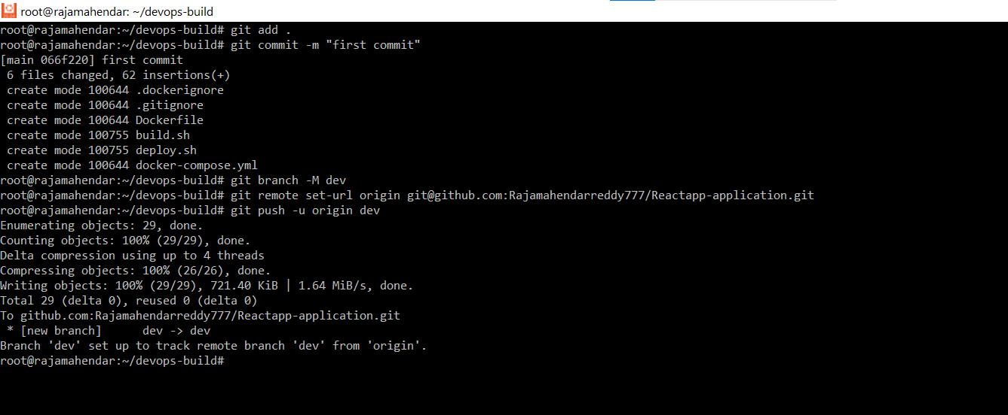

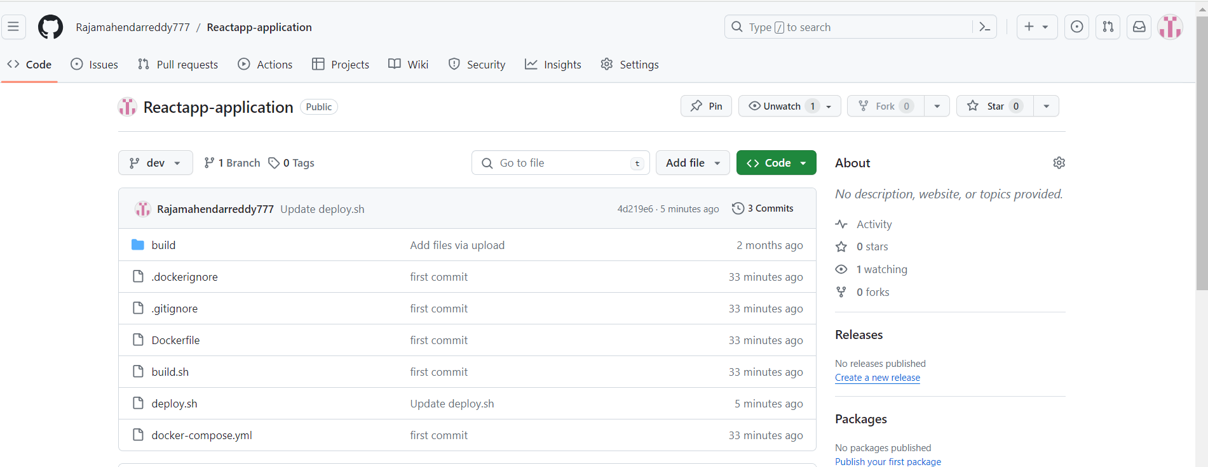

### **Step5. Docker Hub**

Created 2 repos dev and prod.

"Prod" repo as private &

"dev" repo as public.

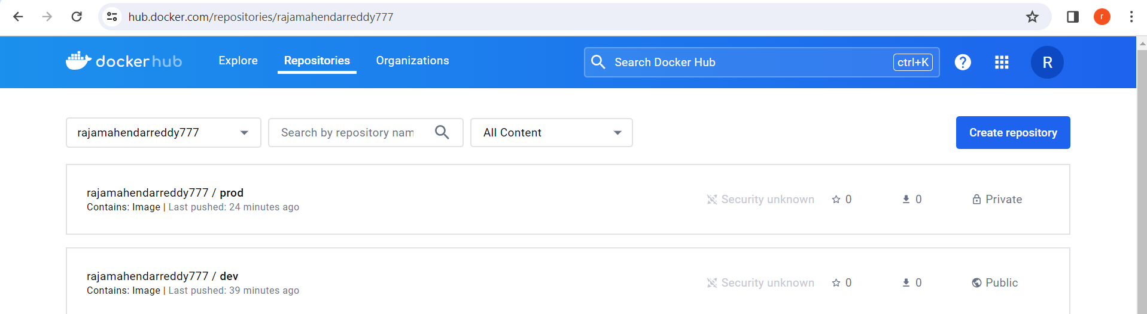

### 

### 

### **Step6. Jenkins**

Install and configure Jenkins according to your needs. Configure it to trigger builds on both the **dev** and **maste**r branches.

steps:

1)Installed jenkins in ec2

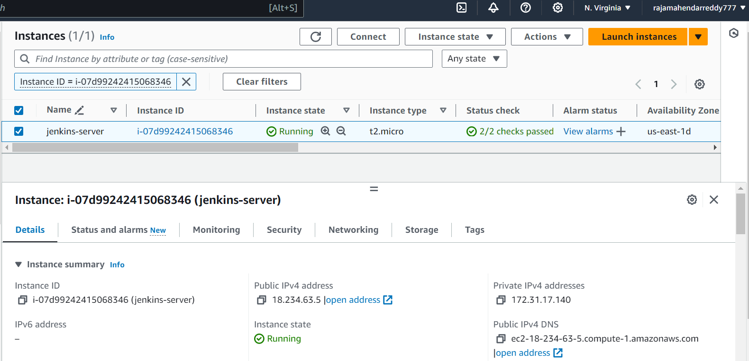

2)ssh to jenkins server

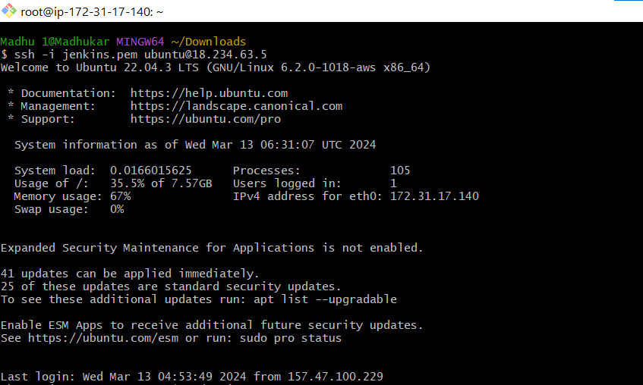

3)Run following commands

# Install Docker

sudo apt-get install -y docker.io

# Start Docker service

sudo systemctl start docker

# Add the user to the docker group

sudo usermod -aG docker $USER

# Enable Docker service to start on boot

sudo systemctl enable docker

# Install Docker Compose

sudo curl -L "https://github.com/docker/compose/releases/latest/download/docker-compose-$(uname -s)-$(uname -m)" -o /usr/local/bin/docker-compose

sudo chmod +x /usr/local/bin/docker-compose

#chmod 777 /var/run/docker.sock

4)sign in jenkins by ip:8080

5)project can be done in two ways either using plugins or using shell

If you want to do by using plugins ,Install all plugins related to projects like

* GitHub Plugin
* GitHub Authentication Plugin
* Docker Pipeline Plugin
* Docker Commons Plugin
* Docker Build and Publish Plugin

6)Create webhook with jenkins

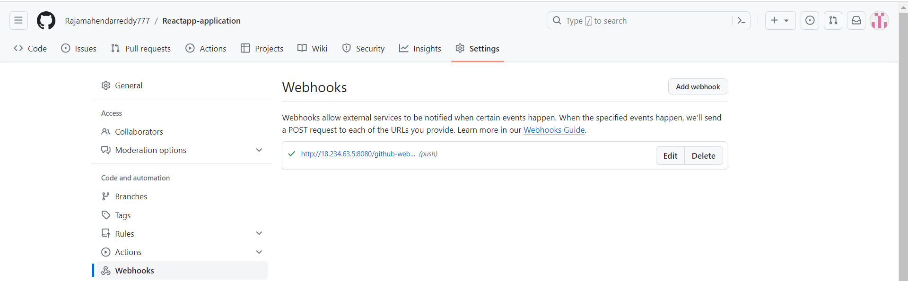

7)If we can give SMTP , we can get mail .

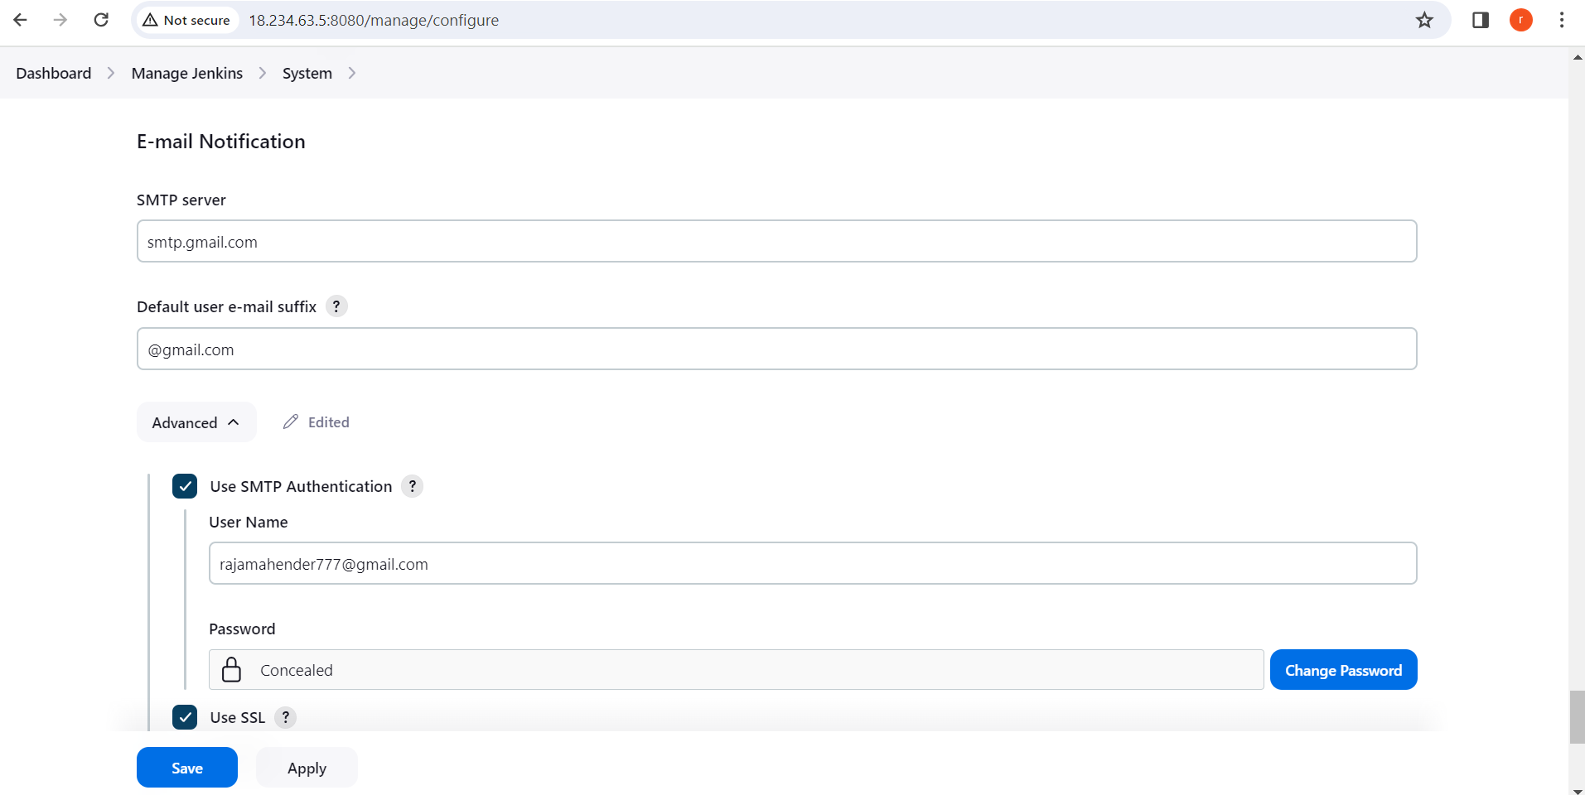

8)create projects in a freestyle or pipeline.

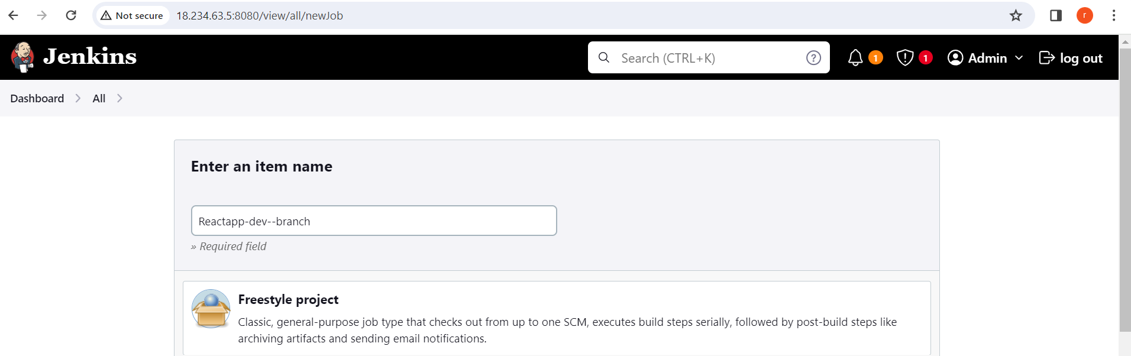

Configure as per our requirements

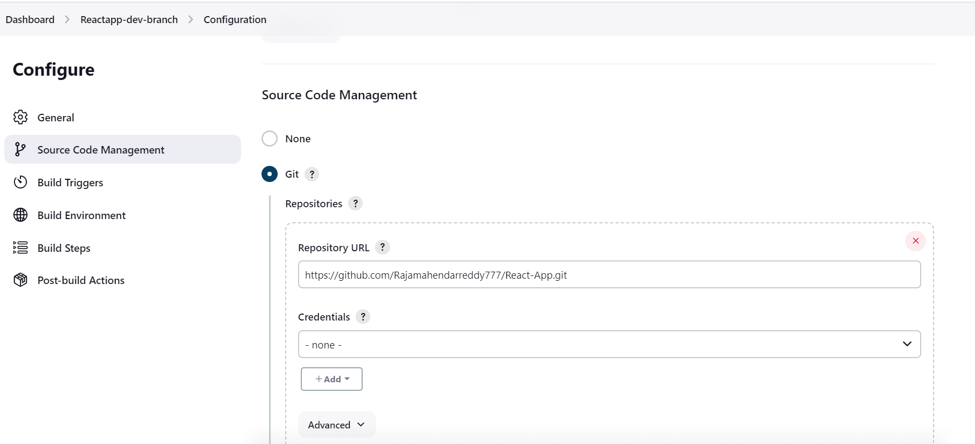

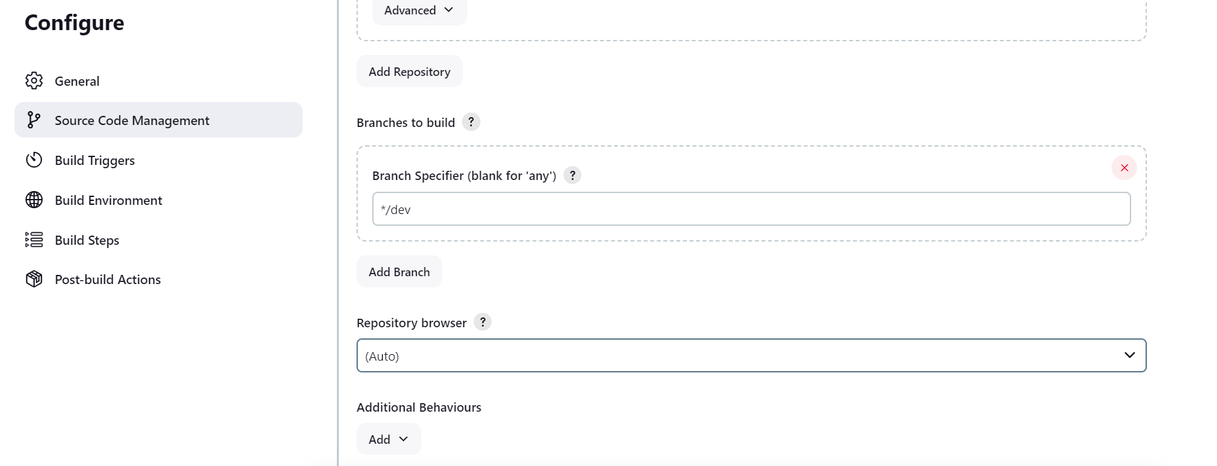

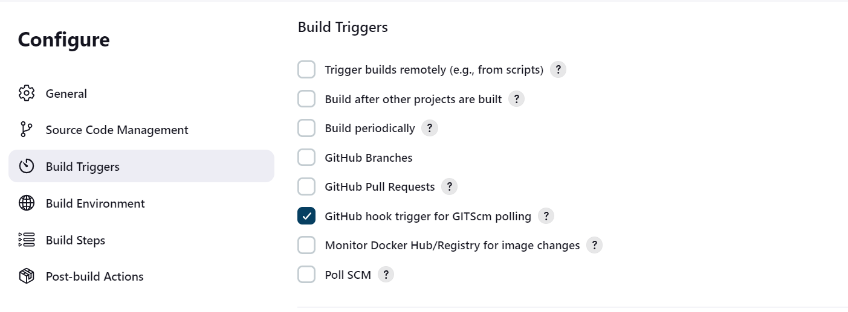

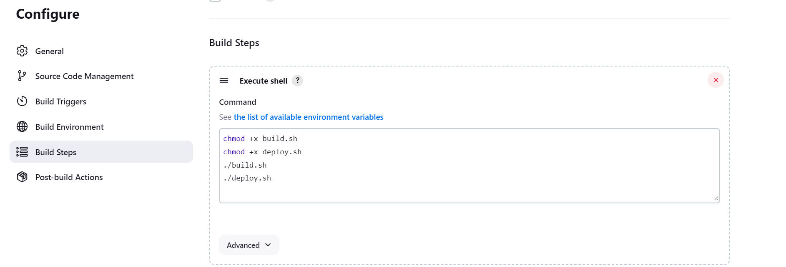

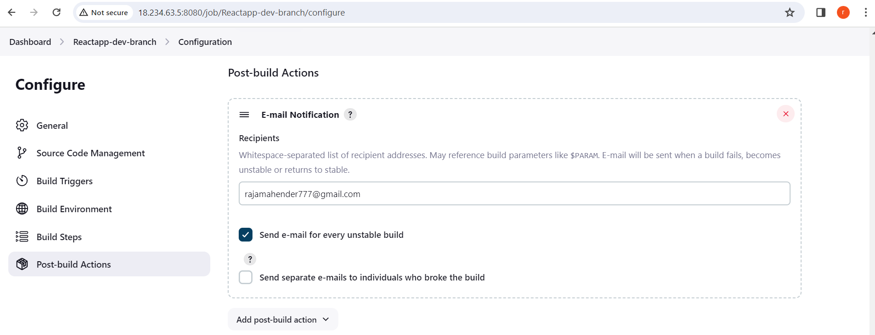

If any commit is done in the git repo it triggers and builds .

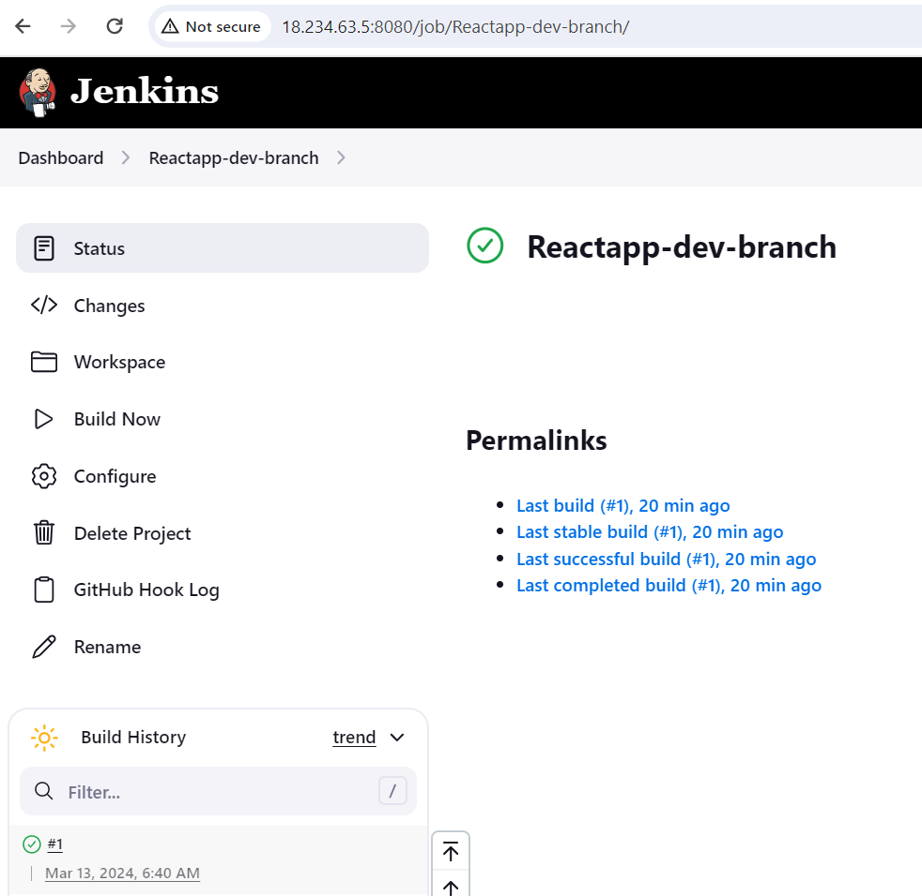

**Console-output:**

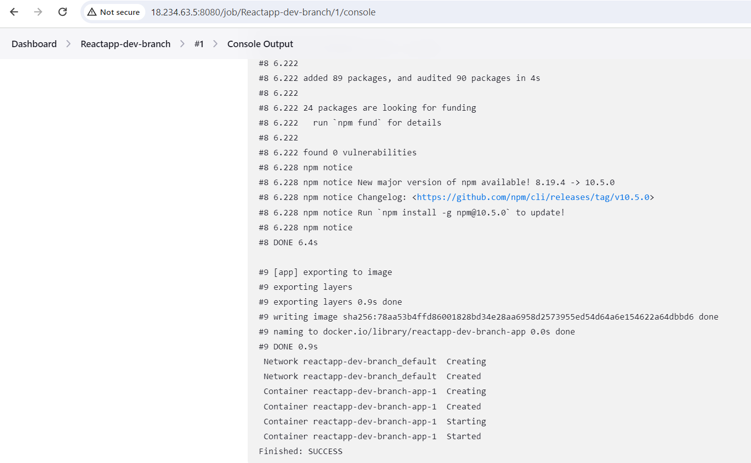

Docker image pushed to my docker hub

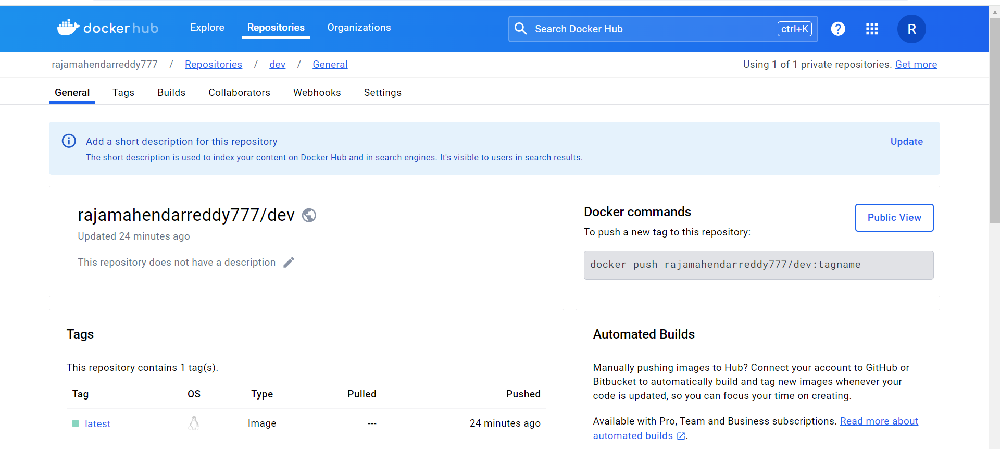

I created one more project for master branch to trigger and build a image and push to prod repo of docker hub with same configurations similar to Reactapp-dev-branch project

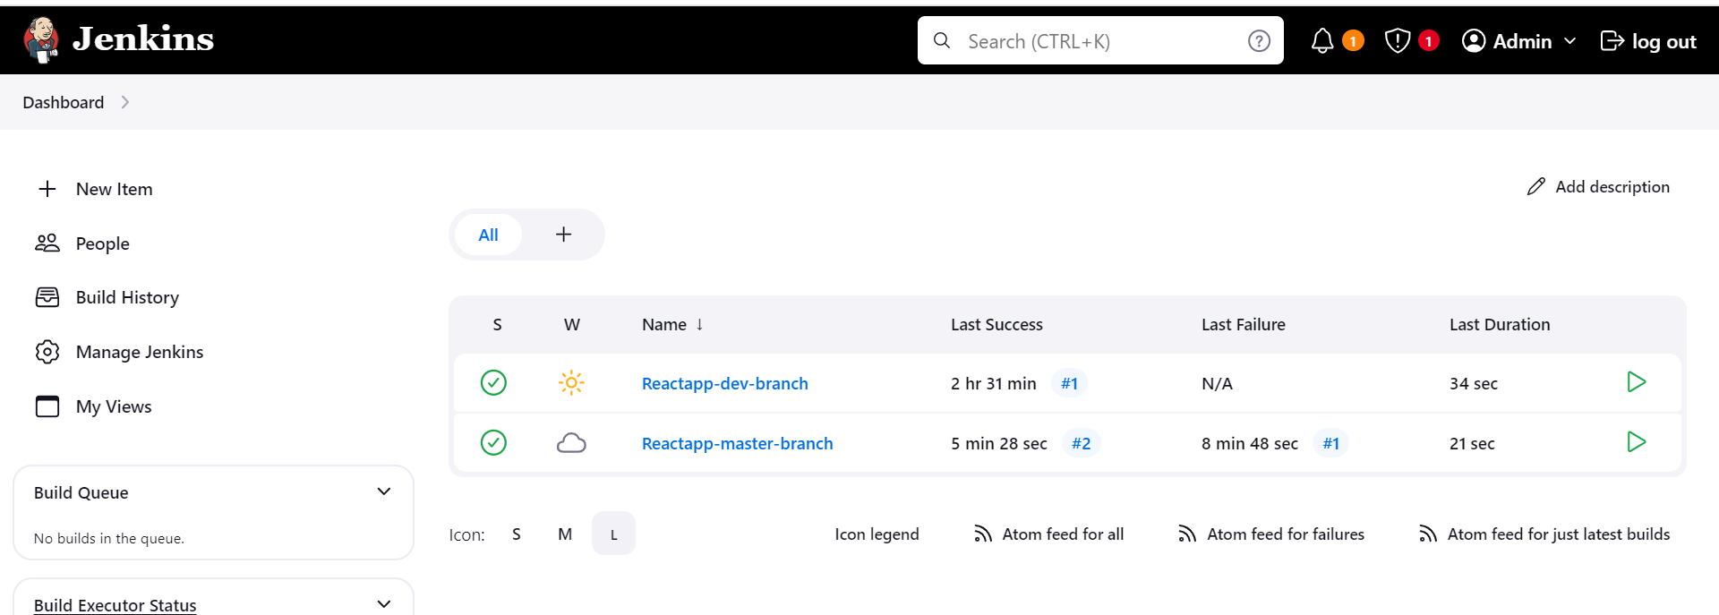

I created one more branch as master and pushed to the remote repository.

I merged dev branch into master branch and it automatically triggered in jenkins and build a image and pushed to prod repo of my docker hub

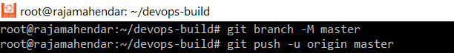

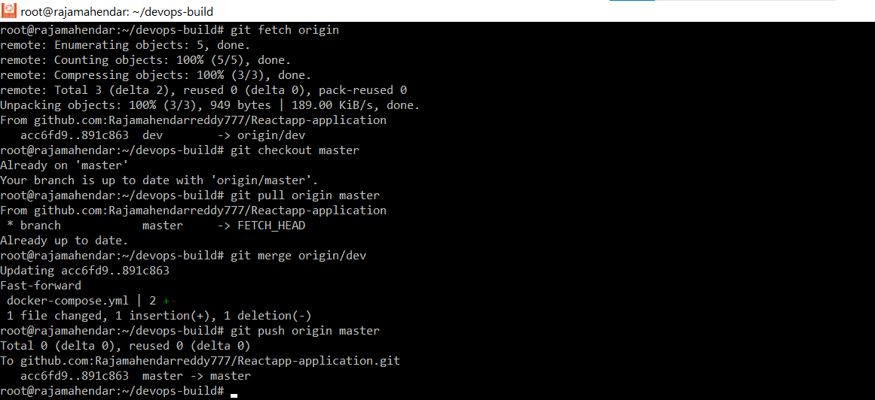

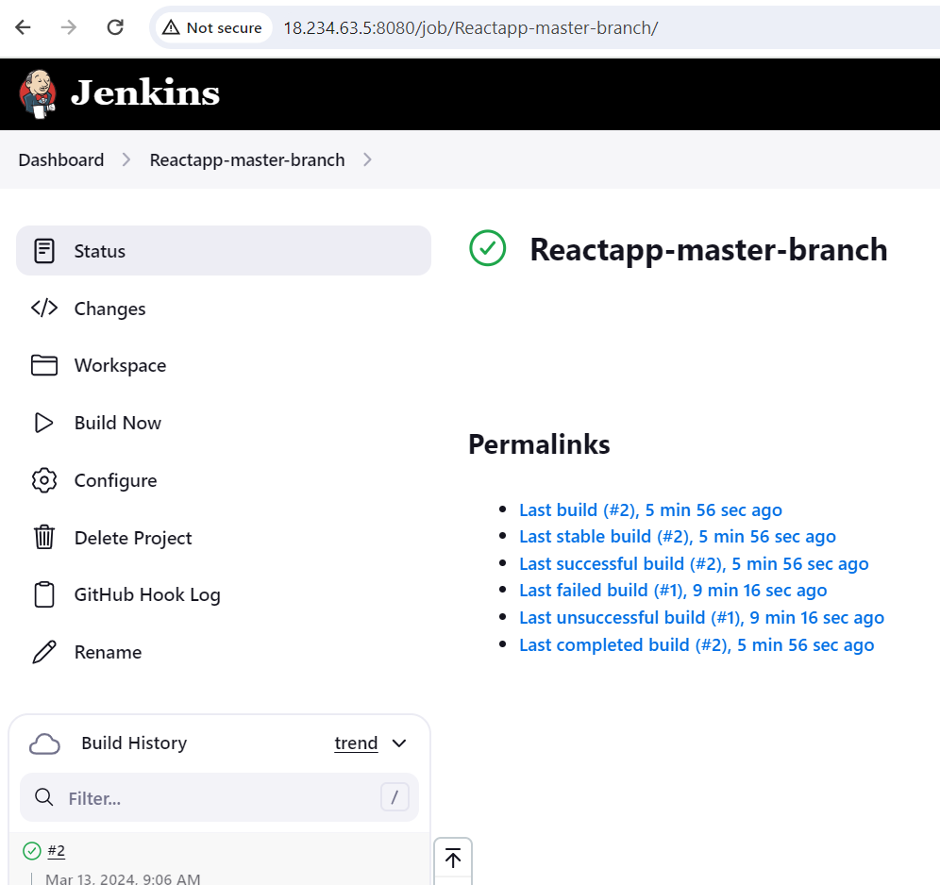

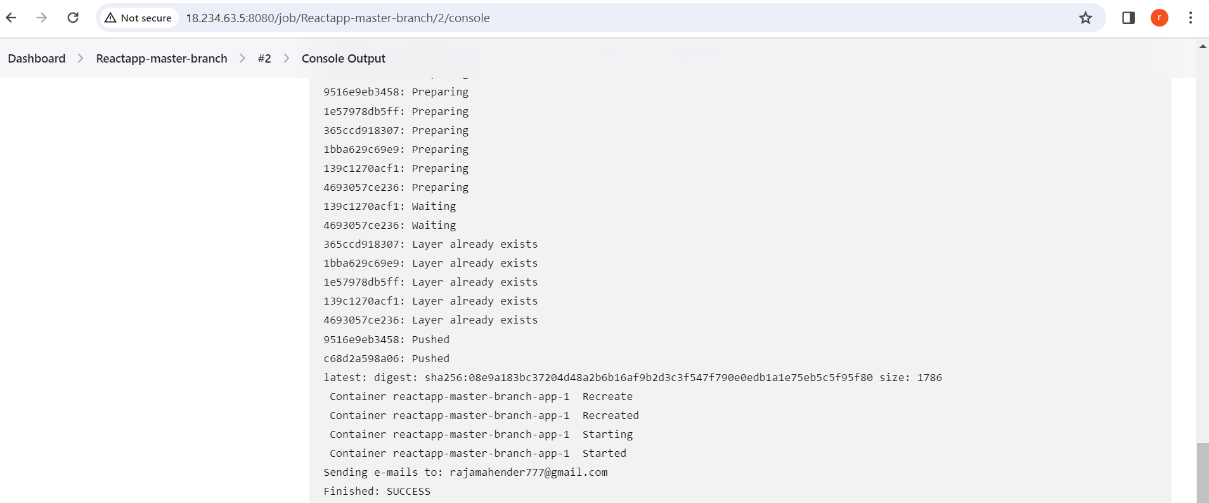

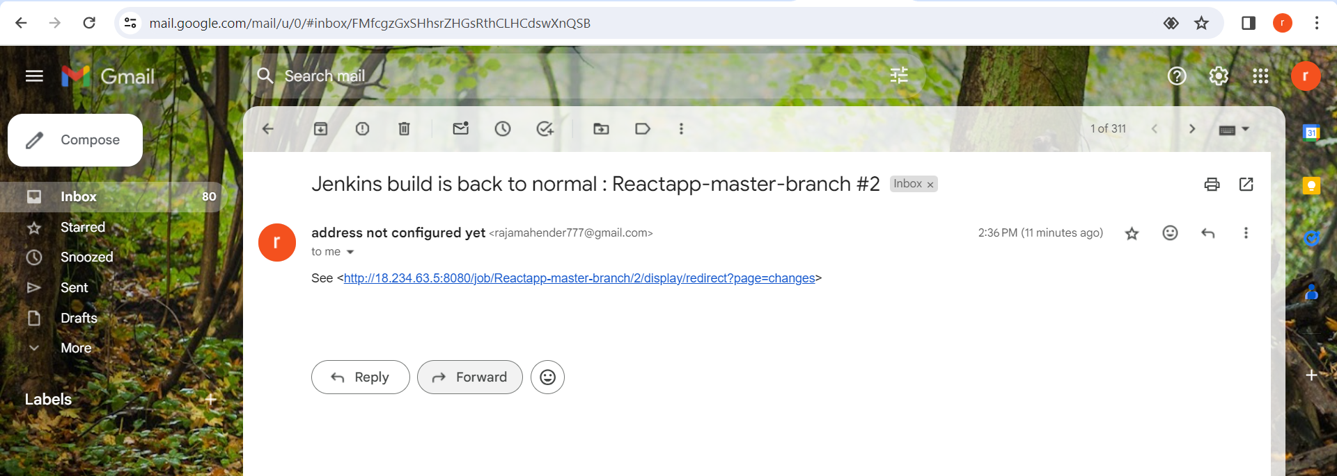

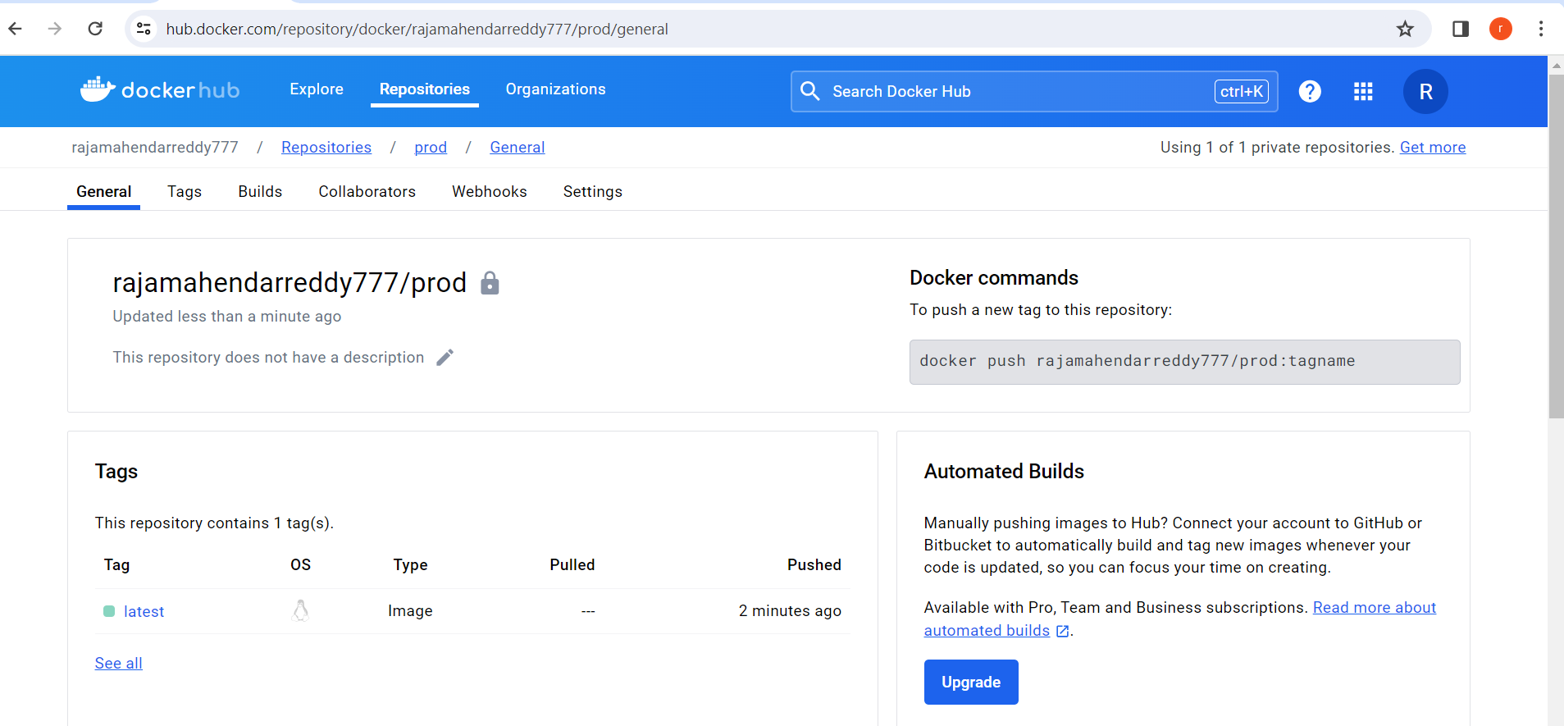

### 

### **Step 7 AWS:**

#### Instance Launch:

* Launch a t2.micro instance on AWS through the AWS Management Console.
* Configure the instance settings and connect it to your existing VPC and Subnet.

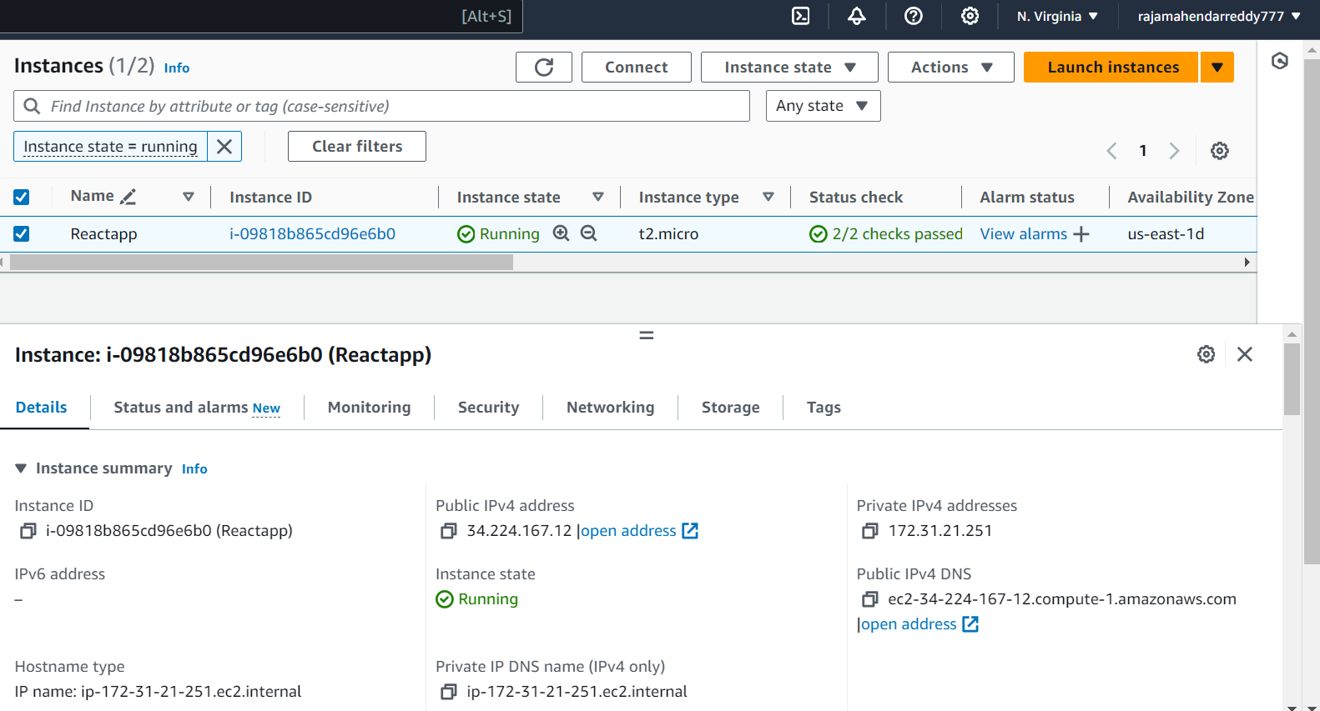

#### 

#### Security Group Configuration:

* Create a new Security Group for your instance.
* Allow inbound traffic on port 80 for everyone (0.0.0.0/0).
* Allow SSH access only from your IP address.
* 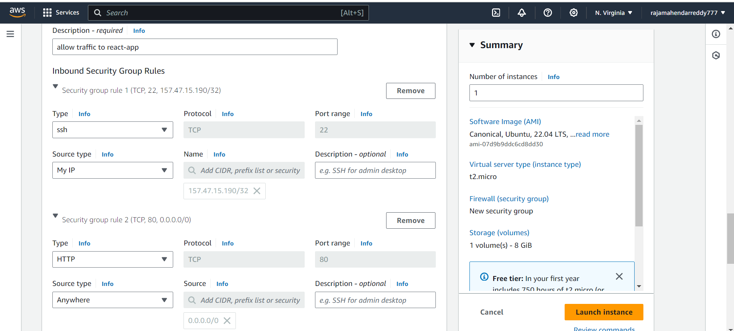
* 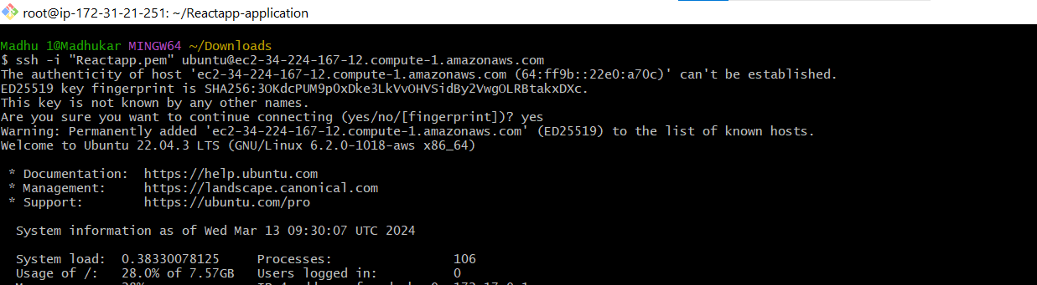

Cloned my Git repo to my Ec2server

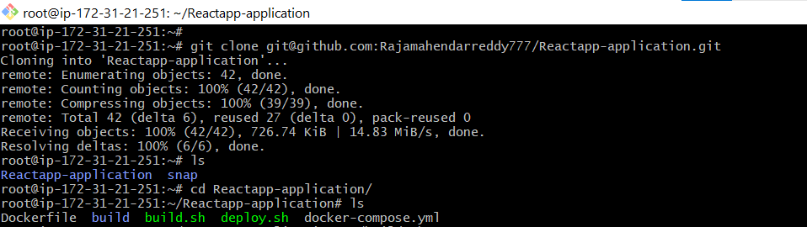

Run the scripts both build.sh and deploy.sh

./build.sh

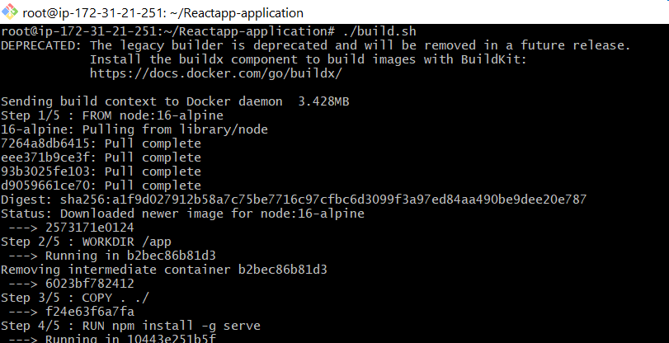

./deploy.sh

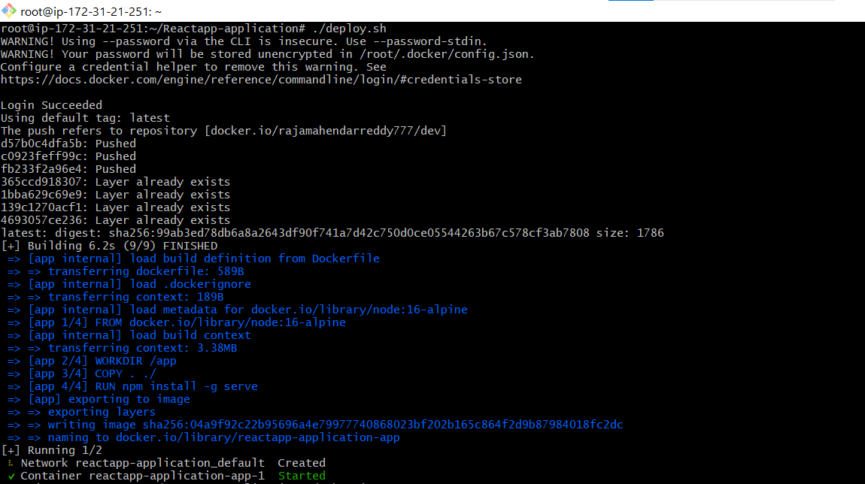

By running the above command docker images are created and the container is running.

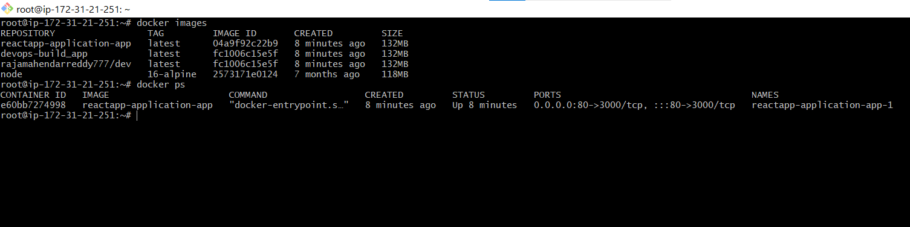

**I pulled my docker image and run the container successfully**

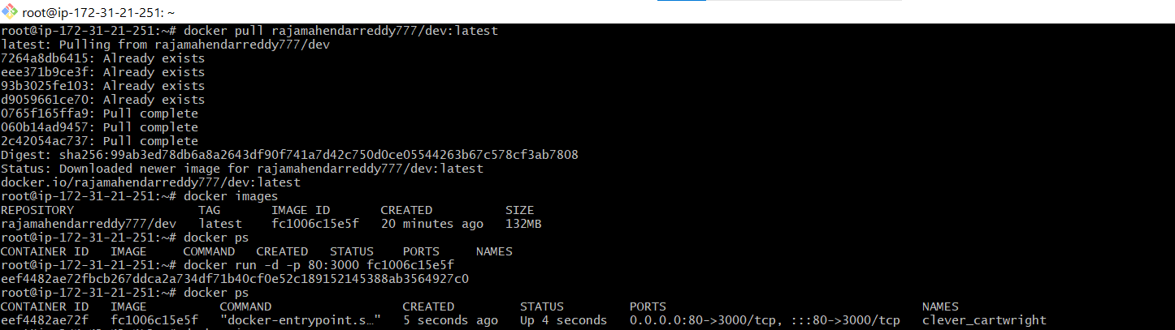

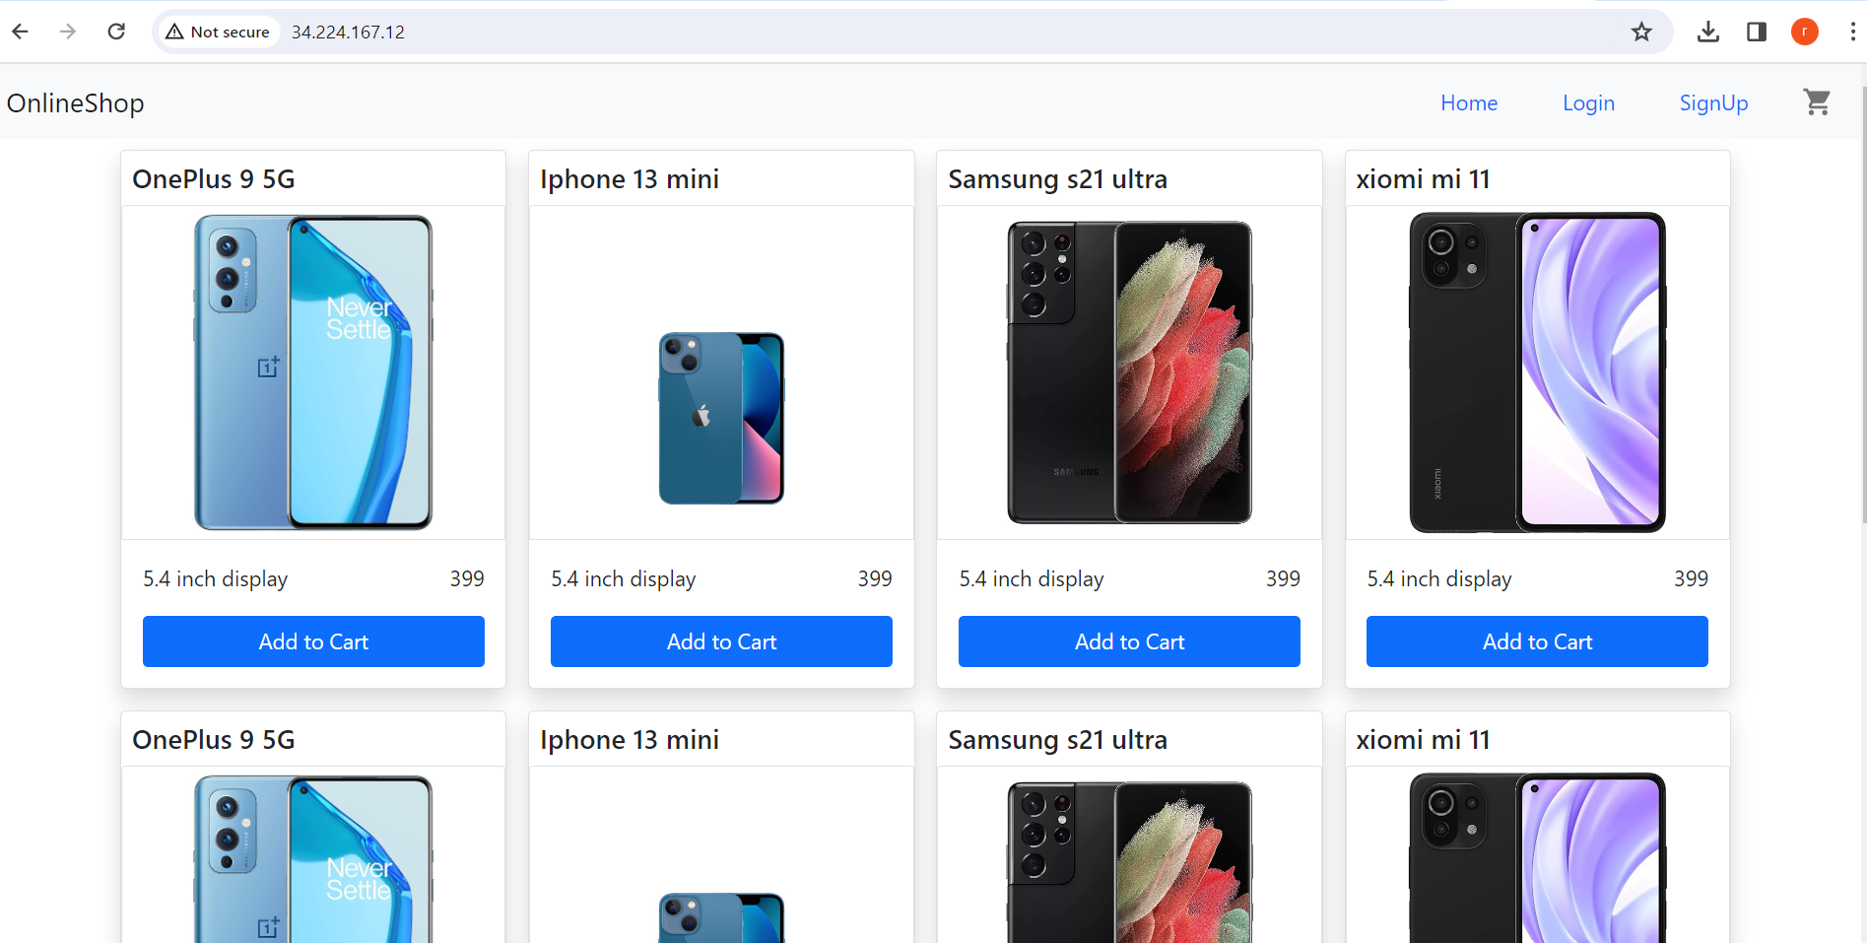

So successfully docker images created and container running on my Ec2 instance.

### **Step8 Monitoring:**

### Monitoring Setup:

* Choose an open-source monitoring tool such as Prometheus with Grafana.

1)Download and extract Prometheus from the official website.

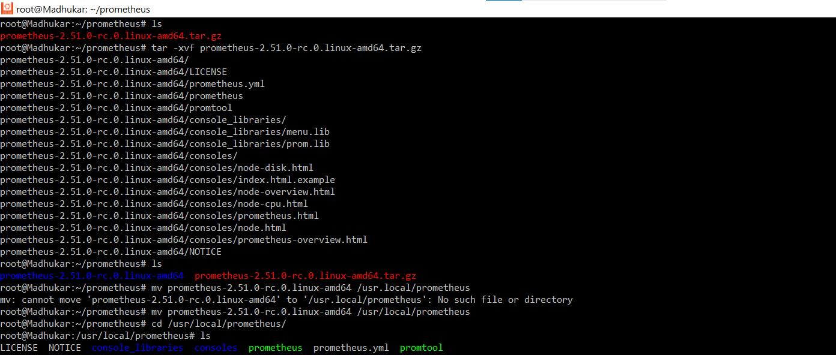

2)Edit the **prometheus.yml** configuration file to include scraping targets for Prometheus itself and Docker

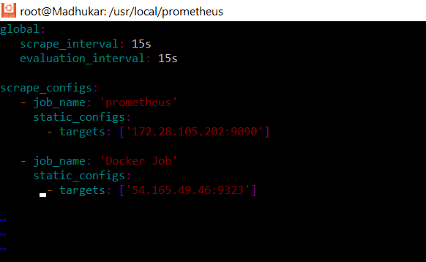

**NOTE:**

In order for Prometheus to gather the metrics of the docker we need to add below content in the /etc/docker/daemon.json file in the docker server

If the daemon.json file is not present in the specified location, create a new file named daemon.json.

***{***

***"metrics-addr" : "0.0.0.0:9323",***

***"experimental" : true***

***}***

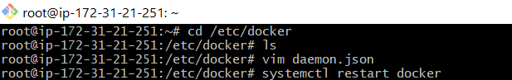

3)Run Prometheus with the updated configuration file.

**./prometheus --config.file=prometheus.yml &**

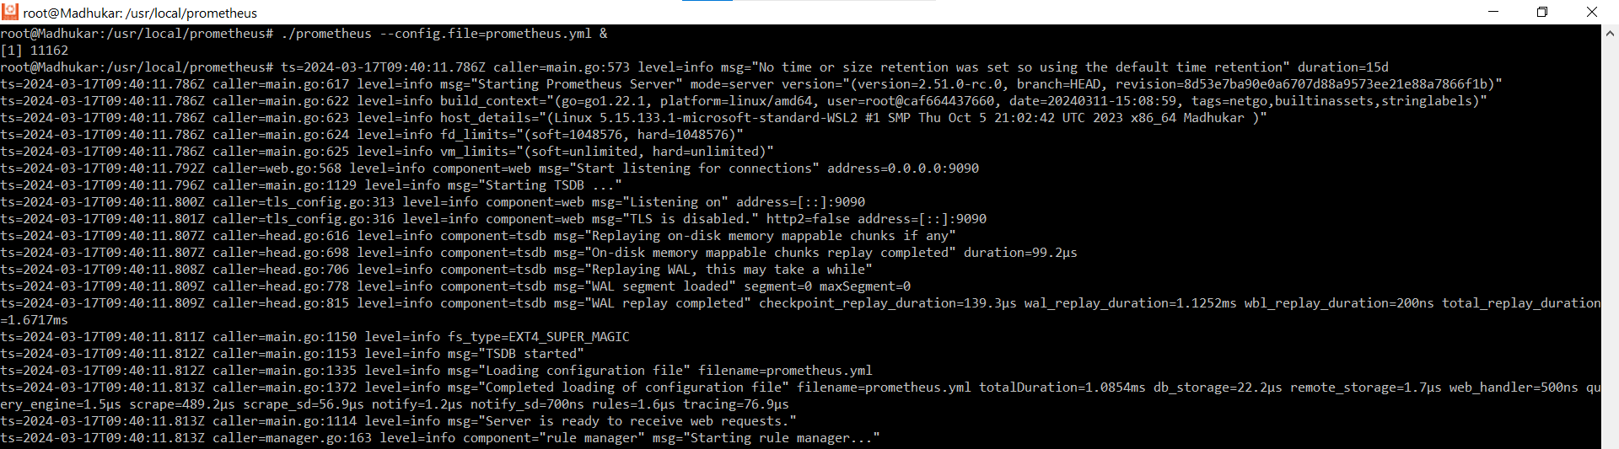

4)Open your web browser and navigate to ***http://localhost:9090*** to access Prometheus's web interface.

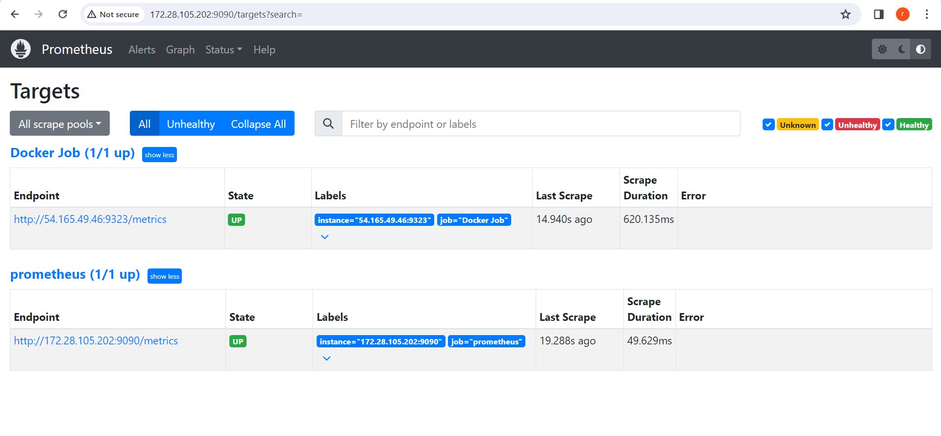

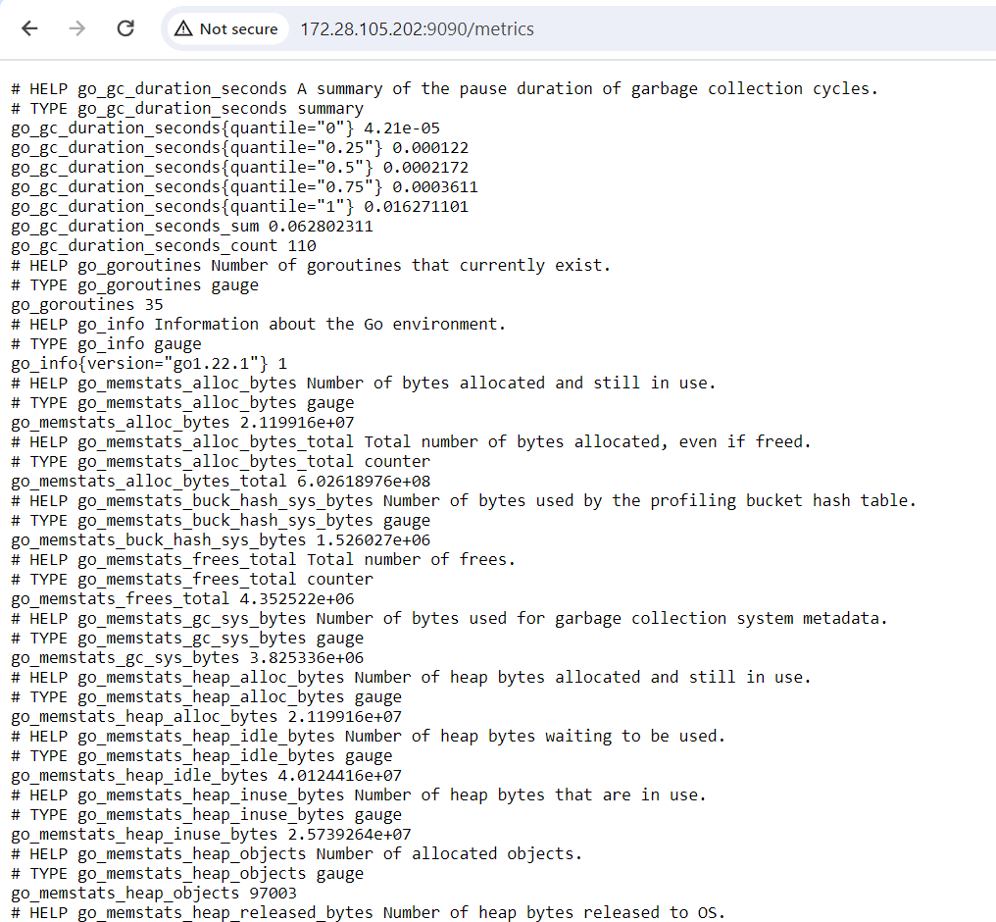

### **Configure Grafana (Optional)**

Optionally, you can install Grafana for visualization and monitoring. Download and install Grafana from the official website, configure it to use Prometheus as a data source, and import dashboards to visualize Docker metrics.

1) steps to Install Grafana on Linux:

<https://grafana.com/docs/grafana/latest/setup-grafana/installation/debian/>

2)After installation, start the Grafana server.

*sudo systemctl daemon-reload*

*sudo systemctl start grafana-server*

*sudo systemctl status grafana-server*

*sudo systemctl enable grafana-server.service*

3)Once Grafana is running, open a web browser and navigate to ***http://localhost:3000*** (default Grafana port).

* Log in with the default credentials (admin/admin), and you'll be prompted to change your password

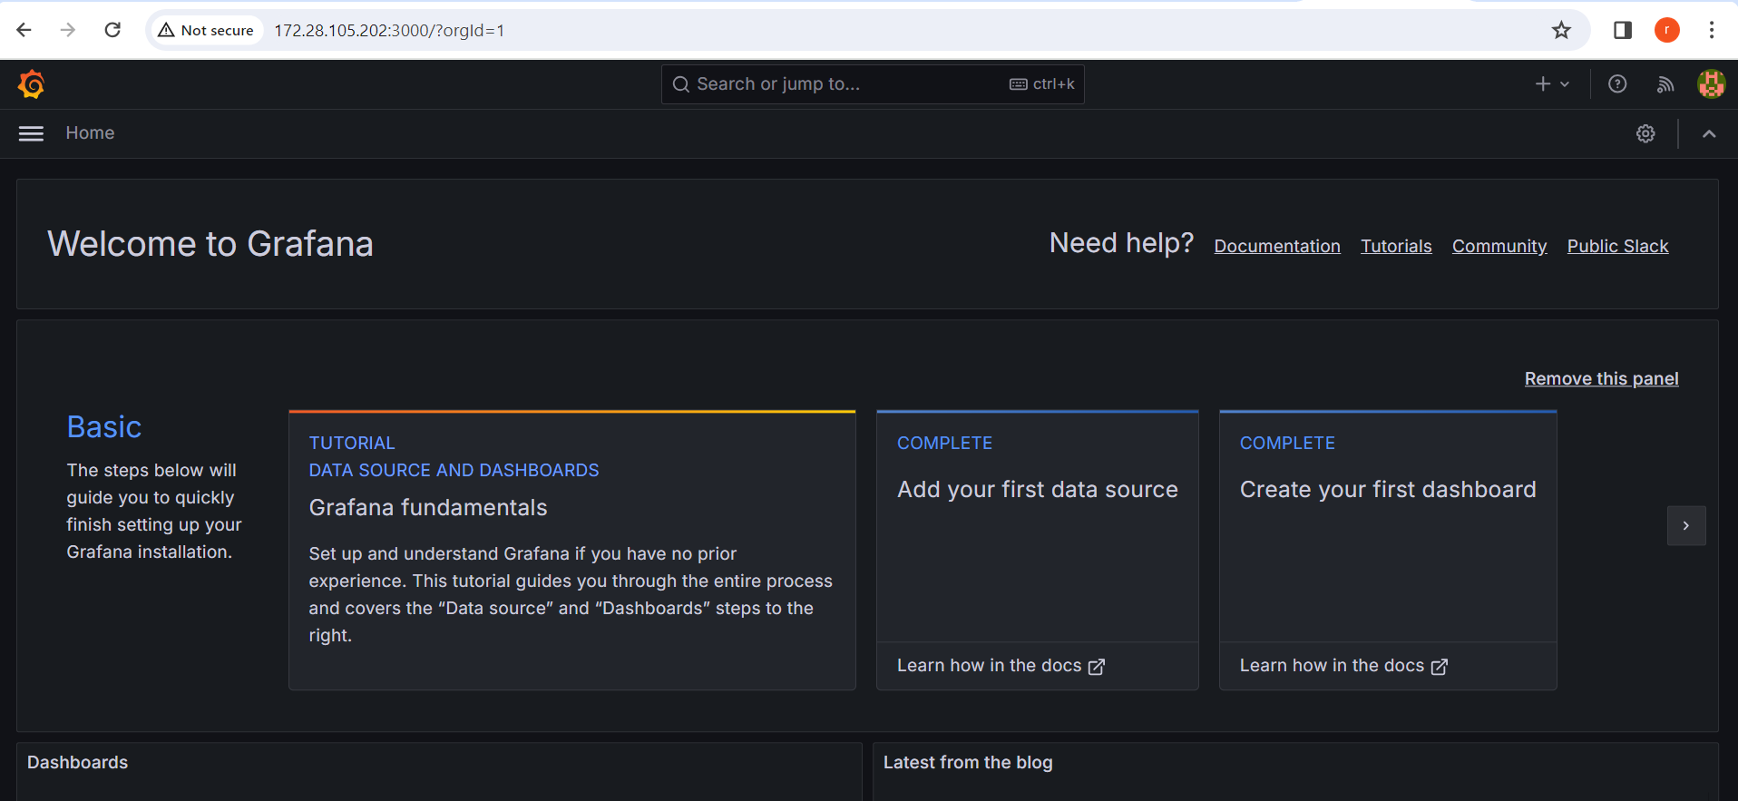

4) After logging in, click on the gear icon (Configuration) in the sidebar, then select "Data Sources."

* Click on "Add data source," select Prometheus, and configure it with the address where Prometheus is running.

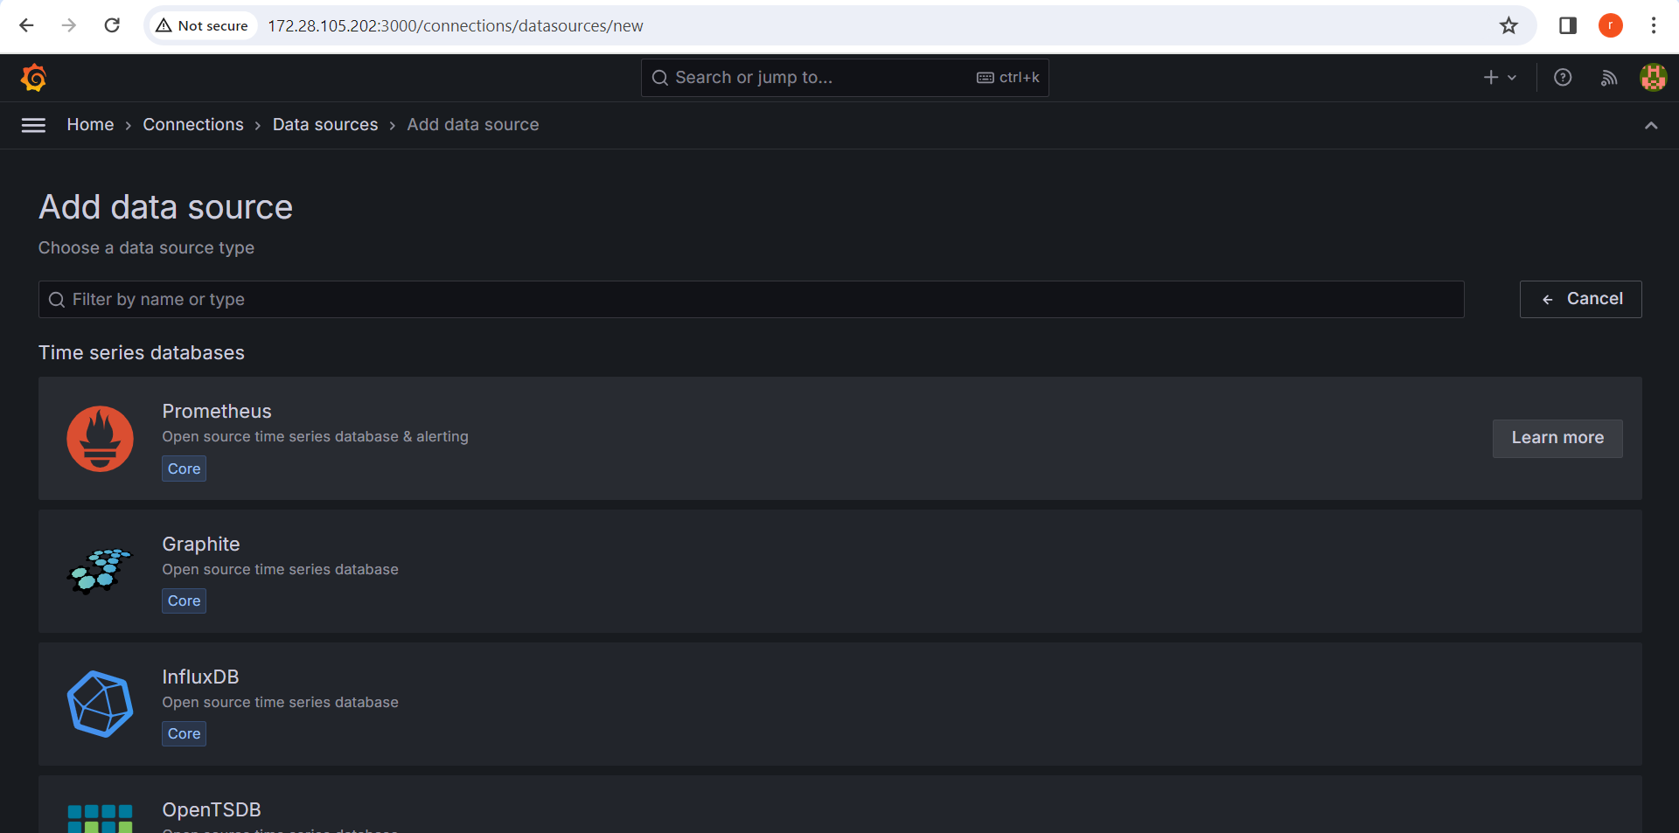

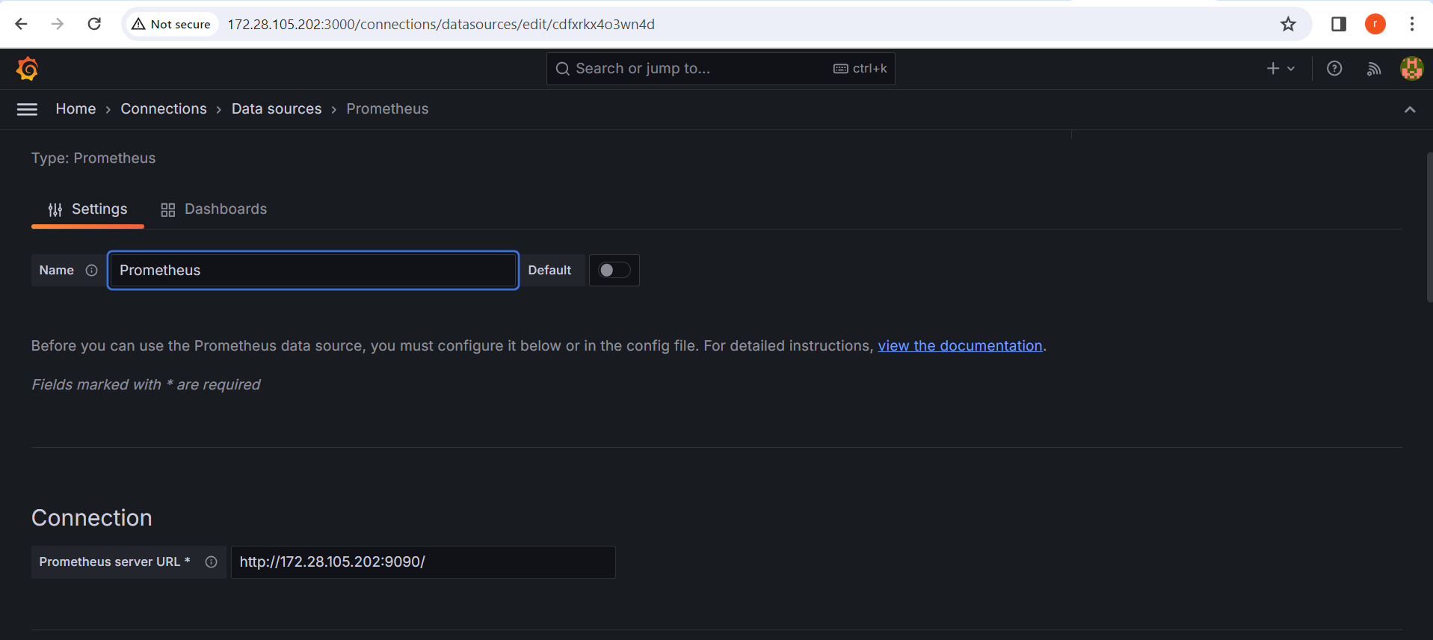

5) Now that Grafana is configured to use Prometheus as a data source, we can start exploring Docker metrics.

* Grafana provides pre-built dashboards for Docker monitoring. You can import these dashboards to visualize Docker metrics more easily.
* Click on the '+' icon in the sidebar and select "Import."
* Enter the ID of the Docker dashboard you want to import. You can find Docker dashboard IDs on the Grafana website or community forums.
* Once the dashboard is imported, you can explore various Docker metrics such as CPU usage, memory usage, network traffic, etc., for your Docker containers.

For this application I am creating a dashboard with 3 panels.

To add or remove panels:

* Click on the "Add panel" button on the top right corner of the dashboard.
* Choose the visualization type (graph, singlestat, table, etc.) and configure the panel settings.
* To remove a panel, click on the panel's title, then select "Delete" from the dropdown menu.

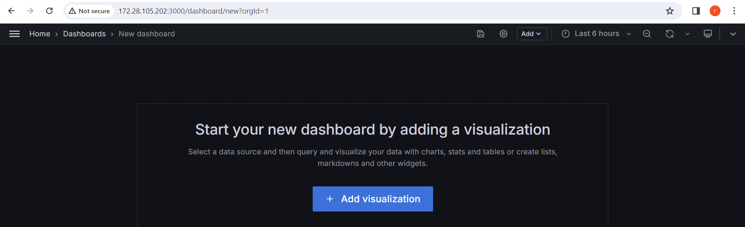

Click on Dashboards and then click on Create Dashboard -> Add Visualization -> select Prometheus Data Source . Then an edit panel will open.

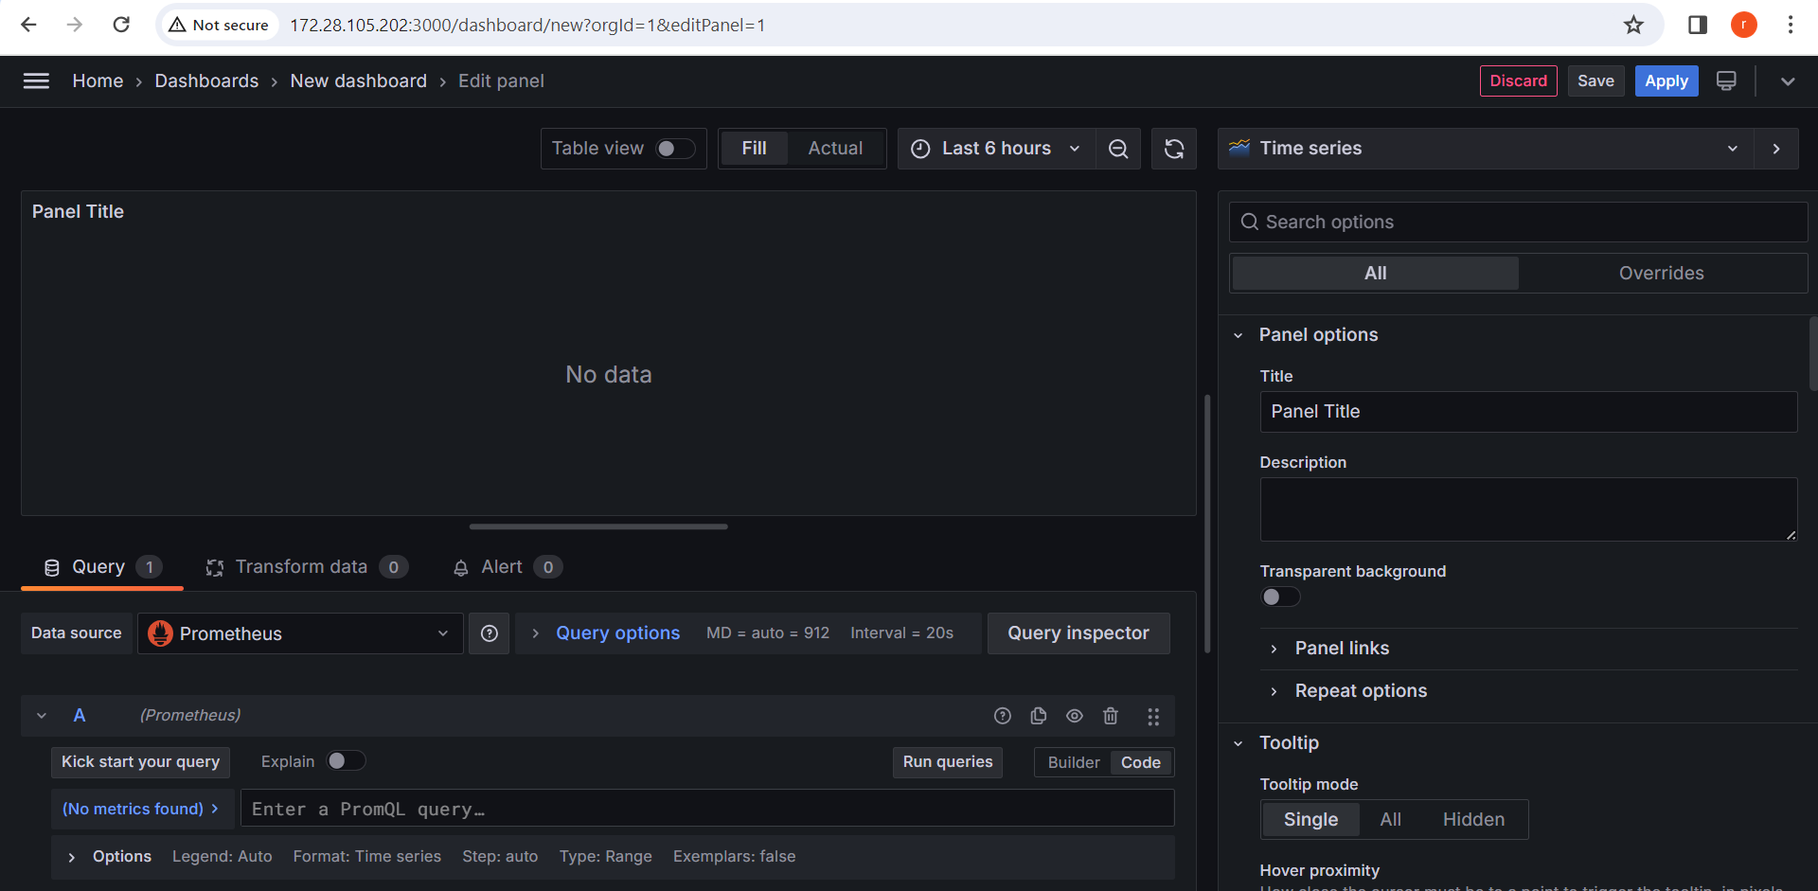

In the above panel configure as per your query and Run queries.

Some examples are Prometheus Docker Metrics.

engine_daemmon_engine_cpus_cpus – Shows number of Engine CPU metrics

engine_daemon_container_states_containers{state=”stopped”} – Shows stopped containers

engine_daemon_container_states_containers{state=”paused”} – Shows paused containers

engine_daemon_container_states_containers{state=”running”} – Shows running containers

1) In the Metrics browser selection select ***engine_daemmon_engine_cpus_cpus*** then select job and **job** name is *docker*. Then clicking Run queries will fetch the number of Engine CPU.

This panel display the Number of CPU’s

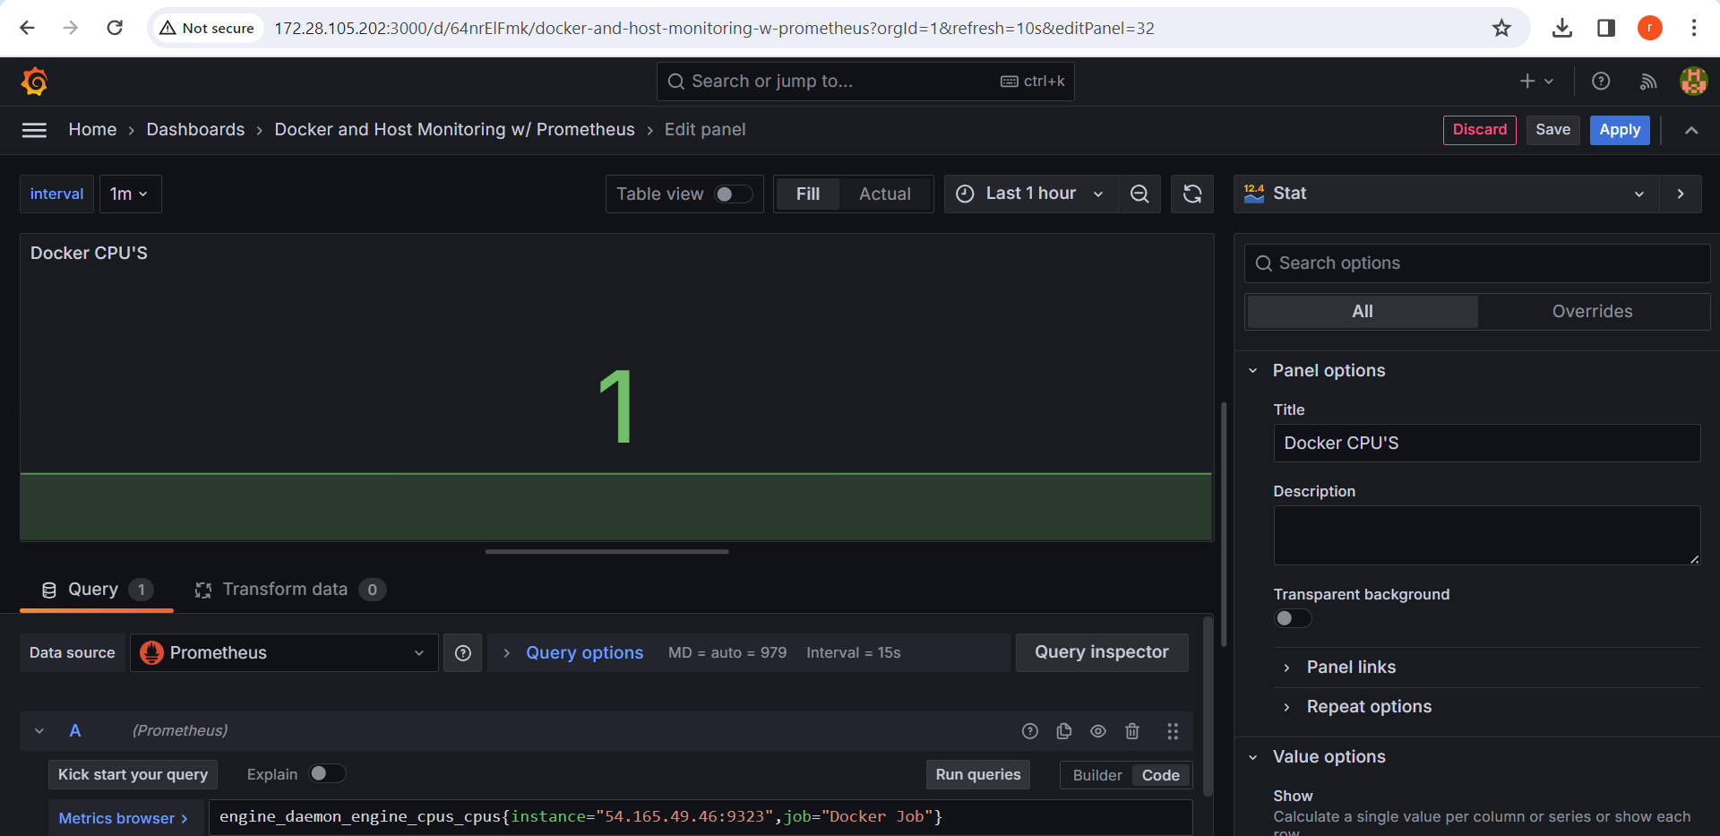

2)This panel will display the paused containers

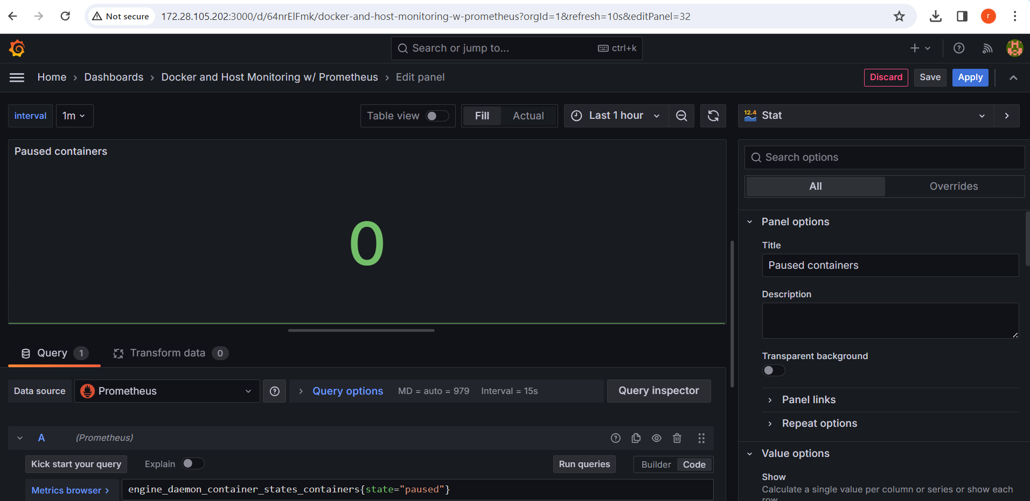

3)This panel will display the number of running containers.

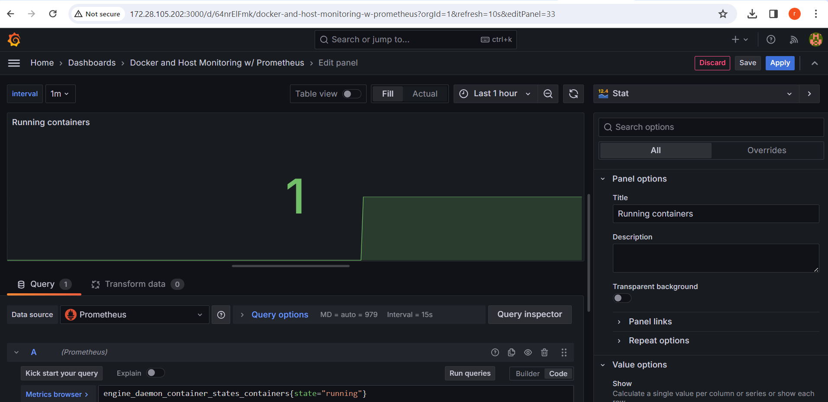

**Set Up Alerts:**

* Alerts in Grafana allow you to receive notifications when certain conditions or thresholds are met in your Docker environment.
* Define alert rules based on specific metrics:
  + Navigate to the dashboard containing the panel with the metric you want to create an alert for.
  + Click on the panel to select it.
  + Click on the bell icon in the panel's title bar to open the alert tab.
  + Click on "Create Alert" to define a new alert rule.
  + Configure the conditions for the alert, such as thresholds, evaluation intervals, and the severity of the alert.
* Set up notification channels:
  + In the alert tab, click on "Notifications" to add a new notification channel.
  + Choose the type of notification channel you want to use (e.g., Email, Slack, PagerDuty, etc.).
  + Configure the settings for the notification channel, such as email addresses, API keys, etc.
* Save the alert rule and notification channel settings.
* Test the alert rule by triggering a condition that meets the alert criteria.
* Once tested, enable the alert rule to start receiving notifications when the conditions are met.

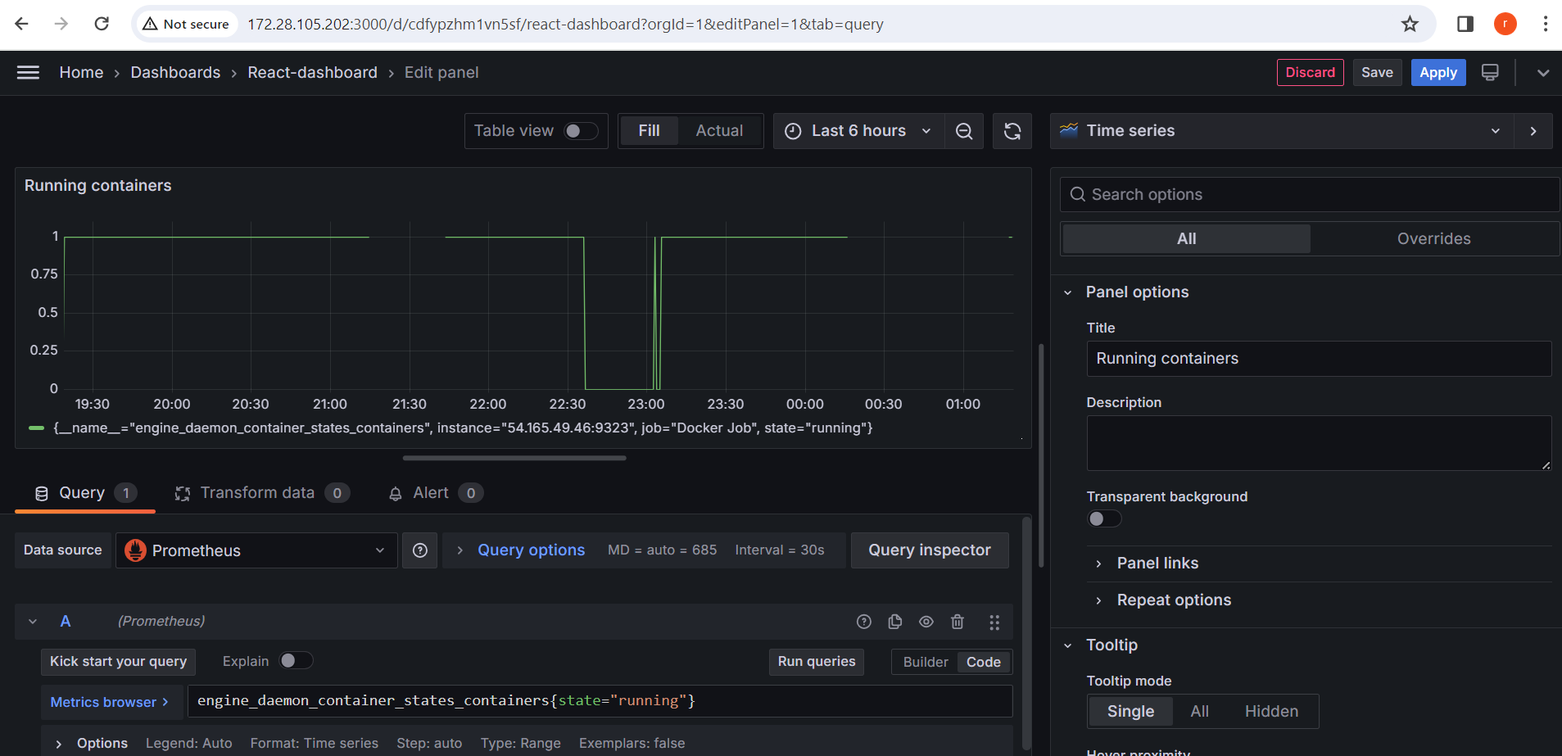

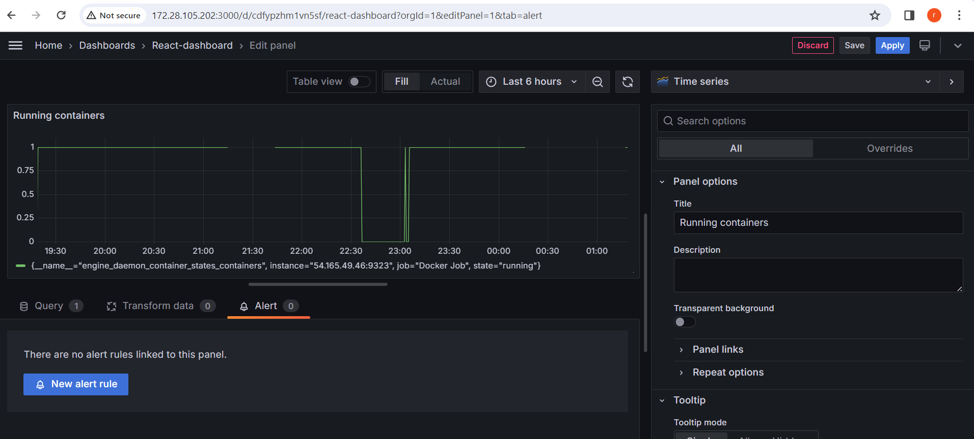

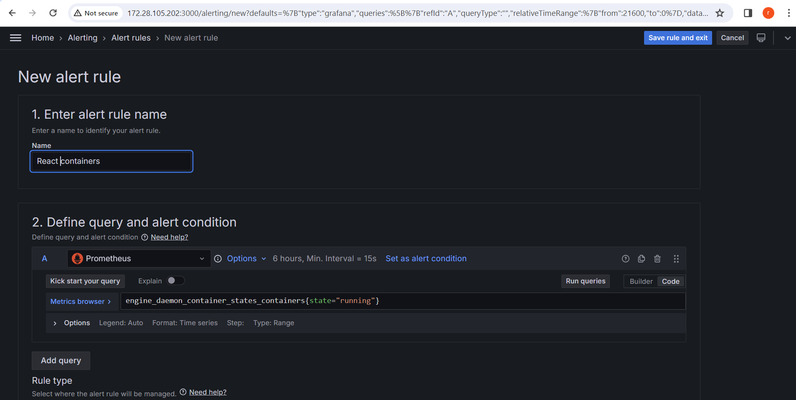

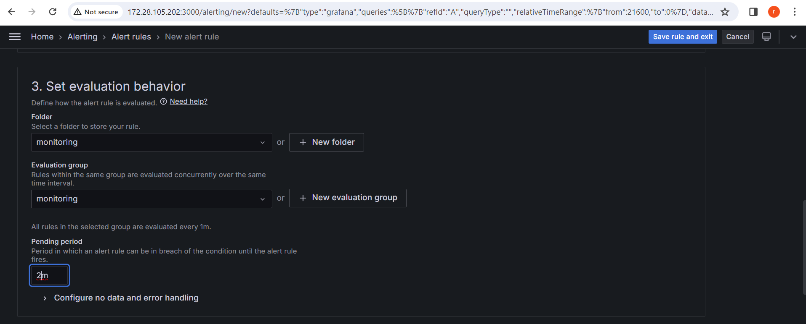

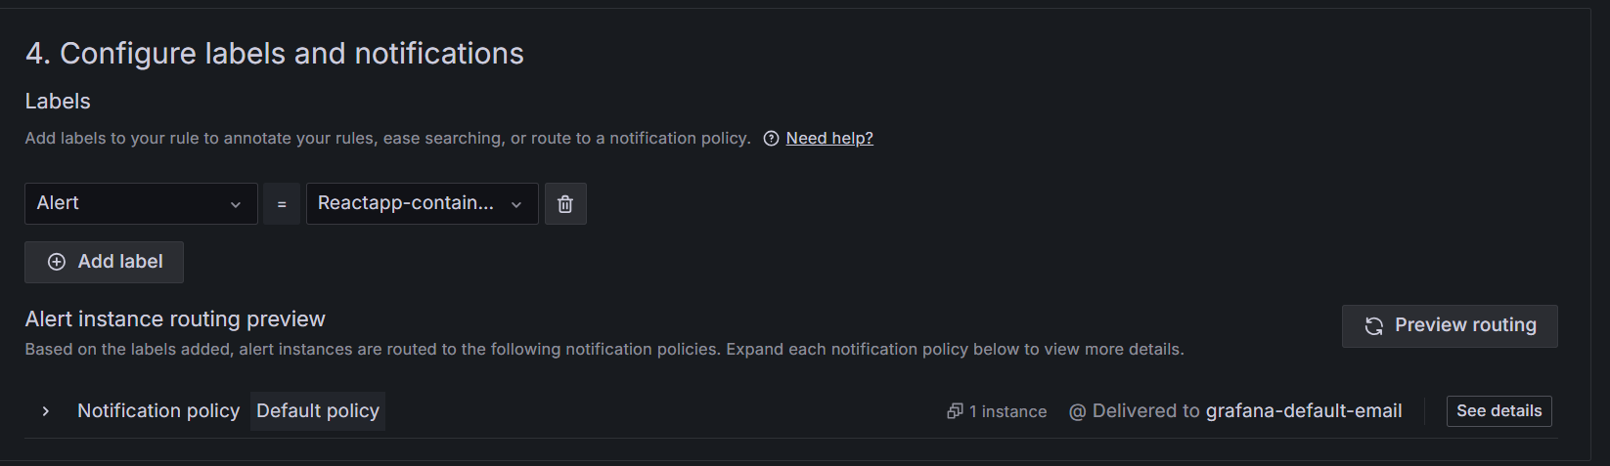

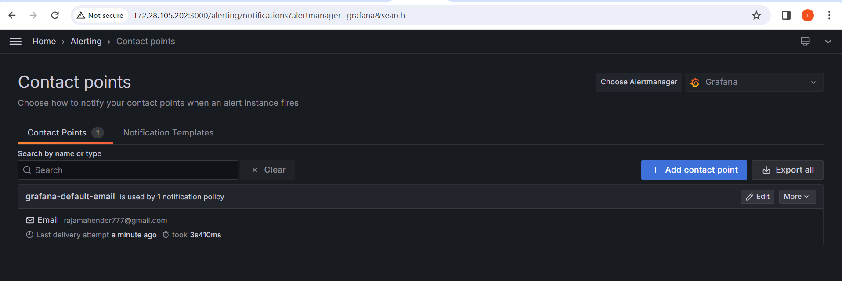

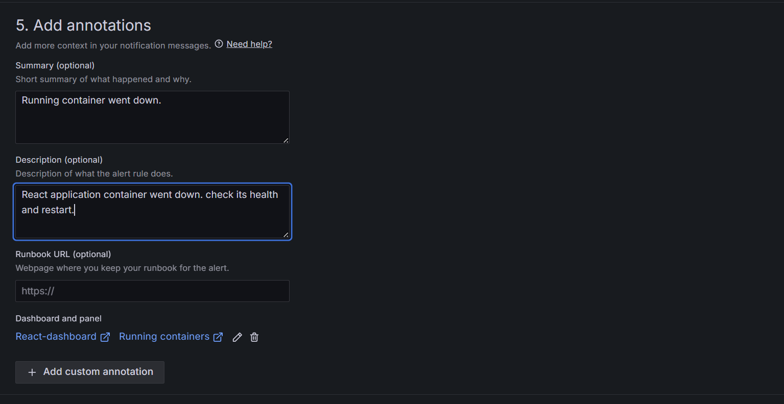

**It shows container health (OK)**

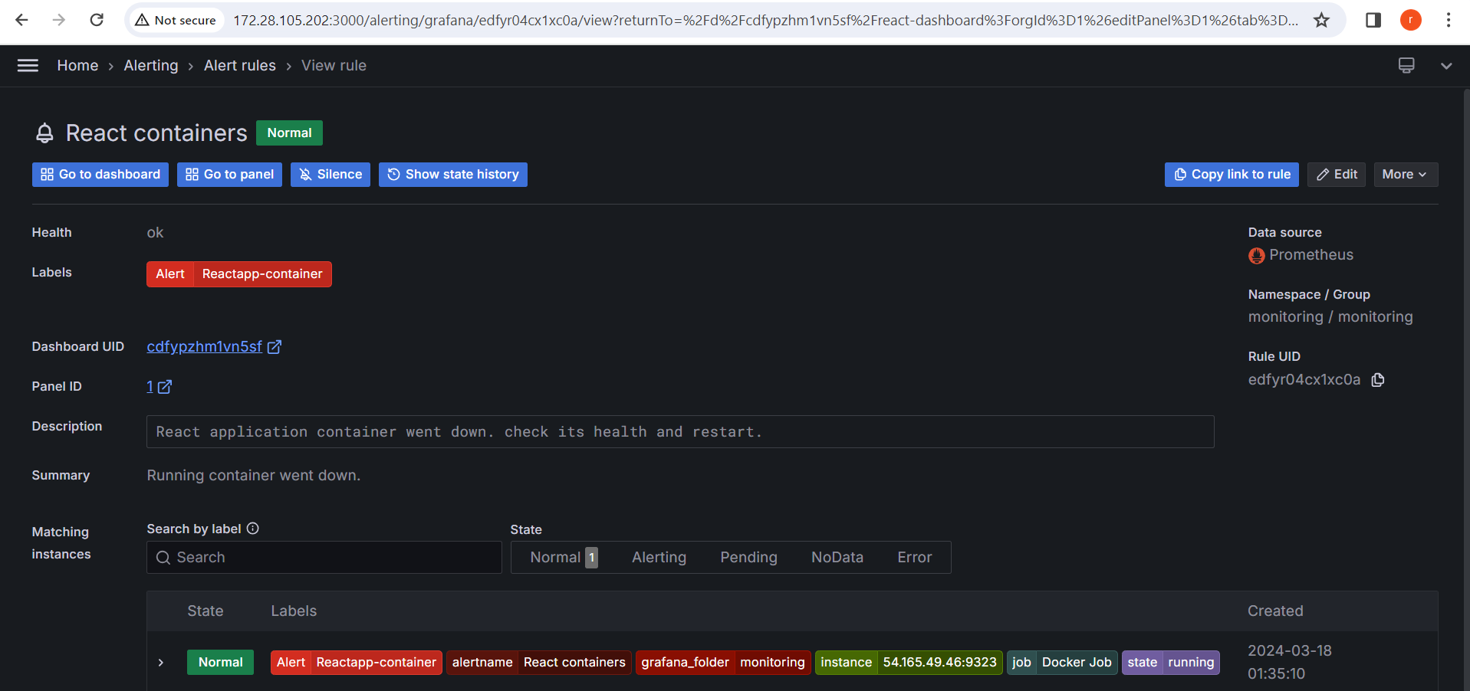

**I got notification in mail as container Running state**

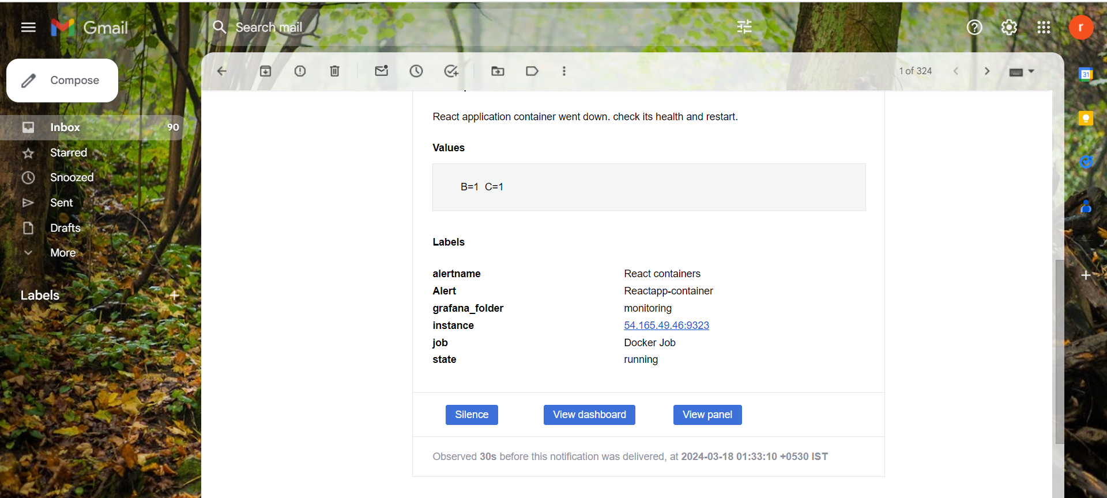

**It shows container health (ERROR)**

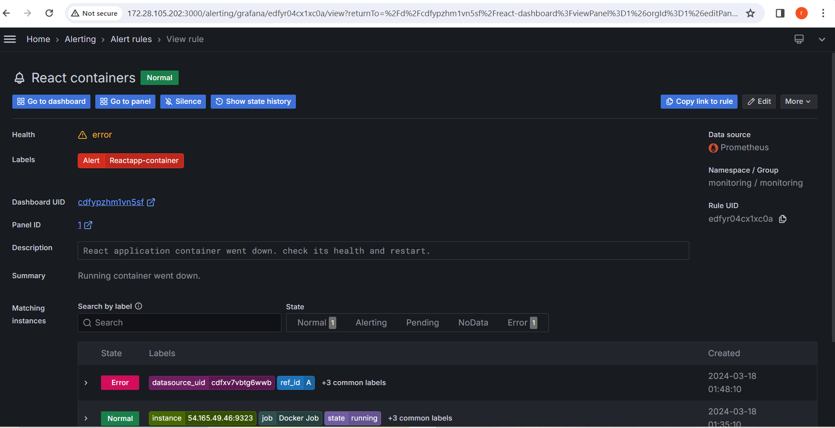

**I got notification when the container went down.**

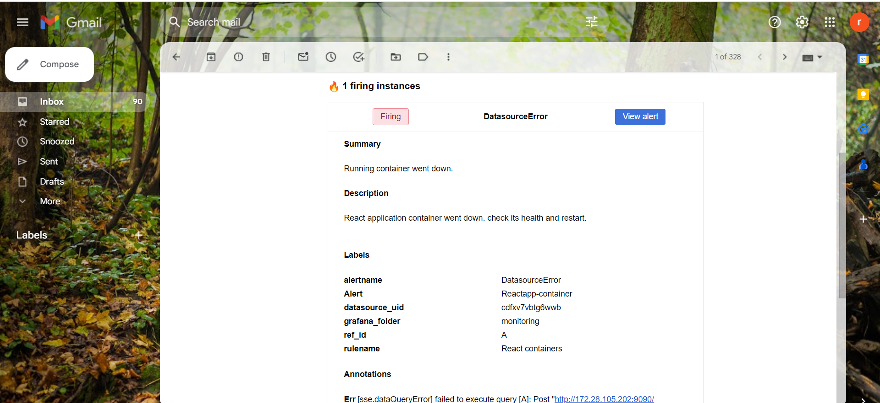

**By customizing dashboards and setting up alerts in Grafana, you can effectively monitor your Docker containers' performance and resource usage, ensuring optimal operation and identifying potential issues before they impact your system.**